


Differences between adult male and female in urine output after Lasix consumption.

Libyan international medical university
Faculty of Applied Medical Science
Name: Bouzied edris alojaly
Student number: 2587

Abstract:
Urination, also known as micturition, is the process of passing urine from the urinary bladder to the outside of the body via urethra, it's the primary method of excretion used by the urinary system, We collect a sample of 12 candidates (6males and 6females) to perform the urine dilution test, first by give a 1 liter of water and 40mg of Furosemide (Lasix), after administration of Lasix in our performed test the result of the collected urine output samples after 6 hours shows that the male's production of urine is higher than females as shown in table1, after administration of Lasix, the male produce more urine output than female after 6hrs collection, but the differences was not significantly correct.⁽¹⁾

Introduction:
Urination, is process of passing urine from the urinary bladder to outside the body via urethra, it's the primary method of excretion used by the urinary system, which is physiologically requires synchronization of the central, autonomic, and somatic nerve systems, while the pontine micturition center, periaqueductal gray, and cerebral cortex are all brain centers that control urine.^{(1,2)}
Urine is a liquid waste product of humans and animal metabolisms, with normal range of 800 to 2,000 milliliters per day in 24-hours (with normal fluid intake about 2 liters per day).^{(3,4)}
Females produce more urination rate per day than males, because of higher volumes of water are imbibed by females,
The majority of compounds that must be removed from the blood, particularly metabolic end products like urea, creatinine, uric acid, and urates, are poorly reabsorbed and hence expelled in considerable volumes in the urine, while some nutritious compounds, such as glucose and amino acids, are totally reabsorbed from the tubules and do not appear in the urine.^{(5,6)}
Urination problems can be caused by a variety of medical issues, including:
1. Urinary incontinence, or inability to contain urine.
2. Polyuria, or excessively large urine output, linked to diabetes mellitus (types 1 and 2) and diabetes insipidus.
3. Oliguria is decreased urine production caused by a problem with the upper urinary system.^{(7,8,9)}
The potent "loop" diuretics, such as furosemide, act on the thick ascending limb (TAL) of loop of Henle, inhibiting the activity of the Na-K-2Cl cotransporter (NKCC2), which raises the rate of urine volume outflow, and to reduce extracellular fluid volume, especially in diseases associated with edema, congestive heart failure, cirrhosis of the liver and nephrotic syndrome, with adverse reactions like: hypotension, circulatory collapse, thromboembolic episodes, ototoxicity, hearing impairment, deafness and vertigo. ^{(10,11)}

Hypothesis is:
There is difference between adult male and female in urine output after Lasix consumption.
Materials and methods:
We collect a sample of 12 candidates (6males and 6females) to perform the urine dilution test, first by give a 1 liter of water and 40mg of Furosemide (FUR or Lasix).
The urine specimens are collected hourly for 6 times,
Urine output = (amount of urine/number of hours) / weigh of patient in kg.
Statistical analysis was performed using an independent t test, if
(P < 0.05) considered significant statistically and if it was (p > 0.05) considered as not significant statistically.
Result/discussion:
As previously mentioned, the "normal" healthy females, produce more urine than males (p = 0.006) and had more voids per liter of fluid intake (p <0.001).
After administration of Lasix in our performed test, the result of the collected urine output samples after 6 hours shows that the male's production of urine is higher than females as shown in table1.
Table1:
Urine output ml (6hr) | gender | subject
302.4ml | female | 1
388.8ml | female | 2
432ml | female | 3
216ml | female | 4
345.6ml | female | 5
518.4ml | female | 6
432ml | male | 7
388.8ml | male | 8
604.8ml | male | 9
518.4ml | male | 10
302.4ml | male | 11
561.6ml | male | 12

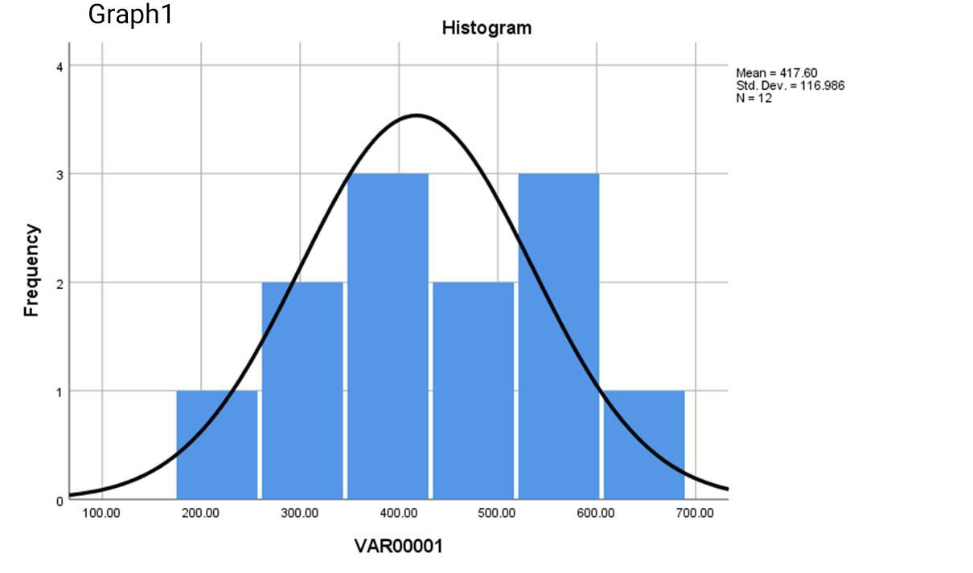
The histogram shows the highest of urine output and the mean of both males and females, in graph1.

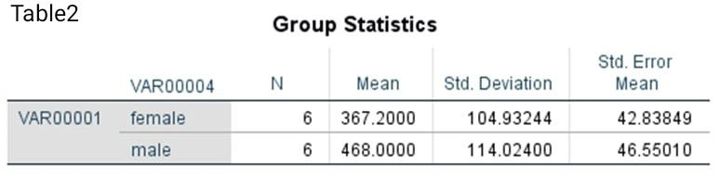
The mean for each was in males more than females also, as shown in table2.

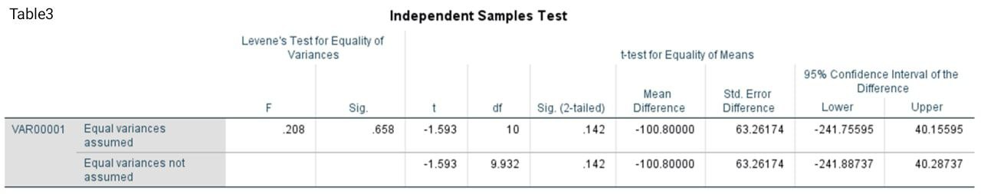
However, the differences was not significantly correct because the P value was above the 0.05, as in table3.

In other study performed on Wistar rats to evaluate the Lasix effect in both sexes.
Rats, both male and female, aged 110–130 days, had unrestricted access to conventional laboratory food and tap water and they were kept in a controlled temperature and humidity setting with proper light cycles 12 hrs.
Four experimental groups used: (1) females (2) males (3) females + FUR and (4) males + FUR.
FUR was given in addition to the inulin dosage as a primer dose (10 mg/kg) and in the infusion solution (20g %).
The result showed that the first two groups doesn't represent any changes in urine output, while natriuretic and diuretic response to FUR was more in female rat's than males, it could be due to the lower abundance of NKCC2 observed in the renal medullae of females which mean a greater amount of FUR reaching the cotransporters and it's probably sufficient to inhibit all of them in female but not in male rats.
The NKCC2 transporter consist of (5'flank) part, that allow the circulating cyclic adenosine monophosphate (cAMP) to bind and exert its action as regulator of NKCC2 actions.
Nitric oxide (NO) decrease the cAMP level, which lead to low NKCC2 transport actions.
In males, high testosterone concentration decreases the cAMP levels, which mean that there is more NKCC2 transporters action, more NA,K,CL and water will reabsorbed from the TAL of Henle and low urine excretion.
While in female has a low testosterone concentrations and high estrogen levels (which act by increasing NO production and decrease its inactivation by oxygen radicals), that’s explain why the female has a greater urine output than male rats. ⁽¹²⁾
Another study, six males and six females normal participants had given oral and intravenous FUR and hydrochlorothiazide. .
Over the next 24 hours, total urine production collected for volume measurements, salt, and potassium content testing.
Between the treatments, there was no statistically significant change in urine flow rate, salt, or potassium excretion rates between male and female individuals.
But, Male participants showed a greater peak sodium excretion rate than female subject's when natriuretic response was adjusted for mg/kg of IV FUR dosage administered.⁽¹³⁾
Conclusion:
After administration of Lasix, males produce more urine output than females after 6hrs collection, but the differences was not significantly correct, which is may be due to the higher susceptibility in male receptors than female to the FUR.
While in rats, the study demonstrate more urine output in females than males, which could be due to the agonist effect of estrogen on the NO production, which causes decrease in cAMP levels lead to NKCC2 downregulation lead to decrease in the K,Na,Cl and water reabsorption and more urine excretion.
The last study doesn't showed that there is changes in urine output for both sexes after FUR administration, but when the dose has been changed for mg/kg, male's production of urine become more frequent than females, which mean that there is a gender related difference on the natriuretic response to diuretics when given as mg/kg.
Reject the hypothesis because there was a contra verse in studies results (first one was not statistically significant while the other two studies shows opposite results).
More studies should be done, and number of individual should be more to avoid the effect of the significance that has happened in the first study, to specify the dose of diuretics, to limit the side effects that can happened on both males and females and to minimize the risk of mistakes that might happen during laboratory diagnosis.
References:
1. Body V. Urine Storage and Elimination. Visiblebody.com. https://www.visiblebody.com/learn/urinary/urine-storage-and-elimination. Published 2022. Accessed June 17, 2022.
2. Malykhina A. How the brain controls urination.
3. Urine | Definition, Composition, & Facts. Encyclopedia Britannica. https://www.britannica.com/science/urine. Published 2022. Accessed June 17, 2022.
4. Encyclopedia M, volume U. Urine 24-hour volume: MedlinePlus Medical Encyclopedia. Medlineplus.gov. https://medlineplus.gov/ency/article/003425.htm. Published 2022. Accessed June 17, 2022.
5. MUELLER E, LATINI J, LUX M et al. GENDER DIFFERENCES IN 24-HOUR URINARY DIARIES OF ASYMPTOMATIC NORTH AMERICAN ADULTS.
6. Anatomy of the Urinary System. Hopkinsmedicine.org. https://www.hopkinsmedicine.org/health/wellness-and-prevention/anatomy-of-the-urinary-system#:~:text=Their%20function%20is%20to%3A,hormones%20to%20regulate%20blood%20pressure. Published 2022. Accessed June 17, 2022.
7. Urinary Incontinence in Older Adults. National Institute on Aging. https://www.nia.nih.gov/health/urinary-incontinence-older-adults#:~:text=Urinary%20incontinence%20means%20a%20person,to%20avoid%20their%20normal%20activities. Published 2022. Accessed June 17, 2022.
8. Polyuria (Excessive Urine Production). WebMD. https://www.webmd.com/diabetes/polyuria-too-much-urine#:~:text=If%20you%20have%20a%20condition,a%20classic%20sign%20of%20diabetes. Published 2022. Accessed June 17, 2022.
9. Oliguria (Low Urine Output): Causes, Symptoms & Treatment. Cleveland Clinic. https://my.clevelandclinic.org/health/diseases/22271-oliguria. Published 2022. Accessed June 17, 2022.
10. What you need to know about water pills (diuretics). Mayo Clinic. https://www.mayoclinic.org/diseases-conditions/high-blood-pressure/in-depth/diuretics/art-20048129#:~:text=Diuretics%2C%20sometimes%20called%20water%20pills,through%20your%20veins%20and%20arteries. Published 2022. Accessed June 17, 2022.
11. Furosemide: Uses, Interactions, Mechanism of Action | DrugBank Online. Go.drugbank.com. https://go.drugbank.com/drugs/DB00695. Published 2022. Accessed June 17, 2022.
12. Brandoni A, Villar S, Torres A. Gender-Related Differences in the Pharmacodynamics of Furosemide in Rats.
13. KL F, JM K, NP L, AH L. Gender effect on diuretic response to hydrochlorothiazide and furosemide. PubMed. https://pubmed.ncbi.nlm.nih.gov/8705087/. Published 2022. Accessed June 17, 2022.

