

Libyan International Medical University
Faculty of Applied Medical Science
Student name: "Yasmeen Adel Saleh Hasan"
Student number / "2876"
Supervisors name: د.انتصار الناجي
Assistant by: أ.ناجي الحمري أ.اسماء الكوافي / /د.لجين الشكماك

Identification of bacteria causing urinary tract infection

Abstract
A urine culture is a laboratory method used to examine urine samples to look for microbes. It follows that determining if there is a urinary tract infection or not by noticing bacterial growth and counting their colonies in culture media identifies the type of bacteria. It was found that Escherichia coli is the most common pathogen causing UTI due to its existence in the large intestine, thus in the anal canal, which is close to the urethra and thus can move out easily into the urinary tract, as well as other gram-negative bacilli, accordingly determine the appropriate antimicrobial treatment. In a total of 24 urine samples collected and tested by conventional culture, significant growth was detected in 2 (16%), no significant growth was found in 8 (66%), and 2 (16%) showed no growth at all in females, while in males, 3 (25%) of the samples show overall no significant growth and 9 (75%) show no growth at all. In addition, we conclude that females have a higher rate of bacterial growth than males due to their anatomical structure; therefore, they suffer from urinary tract infection more than males.
Introduction
A urine culture is a lab test to check for microorganisms or different germs in a urine sample, like Escherichia coli, Proteus, Klebsiella, and Pseudomonas aeruginosa. A urine culture examination can be used to help diagnose urinary tract infections, which are the most common bacterial infections in the world, including bladder infections in children and adults, when there are symptoms such as painful or difficult urination, increased urination frequency, urine that smells bad or appears cloudy or reddish, pressure and pain in the lower abdomen and back, chills, fever, malaise, and tiredness. As well as sex is considered as a risk factor, at least 10–20% of the female populace are affected by asymptomatic UTI, and it was found that Escherichia coli is the most common bacteria causing UTI, especially in women, because their urethra is close to the anus where E. coli is normally present where it helps the body break down and digest the food, as well as other enteric gram-negative rods, including Klebsiella species and Proteus species are ordinary culprits. Urinary tract infection can be caused by Pseudomonas aeruginosa, but it is more likely in health-care-related illnesses, people with anatomic or neurologic abnormalities affecting their urinary system, or those who have had an overabundance of antibiotics.
In addition, gram-positive microbes include Enterococcus species and Staphylococcus saprophyticus, which are not uncommon in young women. Candida species can infect people who have used antibiotics previously and have indwelling Foley catheters. In addition, Adenovirus, BK virus, and cytomegalovirus can also cause hemorrhagic cystitis. These viruses almost cause cystitis in immunocompromised hosts, which include ones who have gone through stem cell transplants. Furthermore, urine culture enables decision of the exceptional remedy. It can also be done after remedy for a urinary tract contamination for confirmation that the microorganism that brought on the contamination is gone.
What's more, empiric remedies are prescribed against E. coli in cases of uncomplicated/simple cystitis. A fluoroquinolone (ciprofloxacin or levofloxacin) or a third-generation cephalosporin, involving ceftriaxone, are used as empiric treatments for community-acquired infections. Antibiotics with a reliable impact against Pseudomonas, such as cefepime, piperacillin, or meropenem, must be used in patients who have had a lot of prior antibiotic intake, have anatomic abnormalities, or have been exposed to the health care environment.

Methods and materials
Gloves, Wire loop, Burner, Urine sample, Culture media (blood agar (non-selective medium) or (MacConkey agar (selective and differential for gram-negative bacilli)), incubator.
1- Put on gloves.
2- Sterilized the wire loop using flame to disinfect it.
3- Removed the cap from the (mid-stream urination) bottle containing the urine sample, dipped the tail of a sterile loop into the urine, and vertically disposed of it, ensuring that there was no urine up the loop.
4- Opened the petri dish; did a one streak throughout the center. Then did cross-zigzag lines with association to first streak, as shown in Figure 1.
5- Incubated the plates aerobically at 35–37 °C for 24 hours.
6- Observe if bacteria have grown or not in the following day, if there was, colonies of bacteria was counted.
7- The rate of infection in women to men was counted.
8- Fisher exact test was used to determine if the proportions of categories in two-group variable significantly differ from each other.
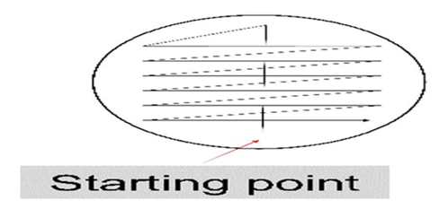
Figure1.show urine sample streaks on culture medium.

Bacterial growth * Gender Cross tabulation
 |  |  | Gender |  | Total
 |  |  | Male | Female | Total
bacterialgrowth | 1.00 | Count | 9 | 2 | 11
bacterialgrowth | 1.00 | % within bacterialgrowth | 81.8% | 18.2% | 100.0%
bacterialgrowth | 1.00 | % within Gender | 75.0% | 16.7% | 45.8%
bacterialgrowth | 2.00 | Count | 3 | 8 | 11
bacterialgrowth | 2.00 | % within bacterialgrowth | 27.3% | 72.7% | 100.0%
bacterialgrowth | 2.00 | % within Gender | 25.0% | 66.7% | 45.8%
bacterialgrowth | 3.00 | Count | 0 | 2 | 2
bacterialgrowth | 3.00 | % within bacterialgrowth | 0.0% | 100.0% | 100.0%
bacterialgrowth | 3.00 | % within Gender | 0.0% | 16.7% | 8.3%
Total |  | Count | 12 | 12 | 24
 |  | % within bacterialgrowth | 50.0% | 50.0% | 100.0%
 |  | % within Gender | 100.0% | 100.0% | 100.0%
Results

Table 1.show proportions of categories in two-group variable.

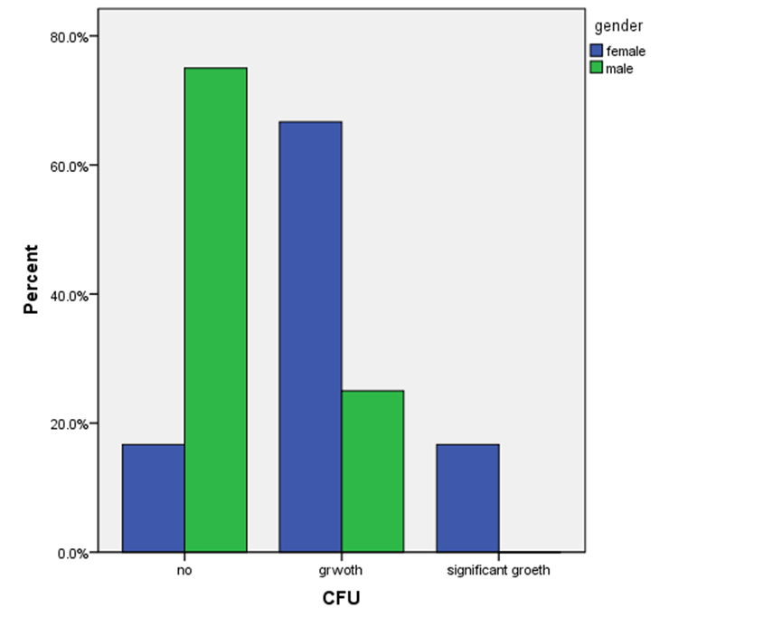
1. Par chart. Proportions of categories in two-group variable.

Hypothesis
H0: no association between gender and colonies number (bacterial growth).
Ha: there is an association between gender and colonies number (bacterial growth).
Assumption
Random sample: samples are randomly selected from the population.
Independence: observation are independent from each other (no matched pairs).

SPSS output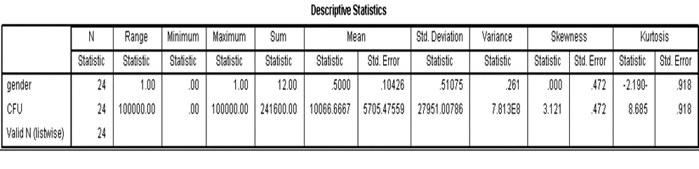
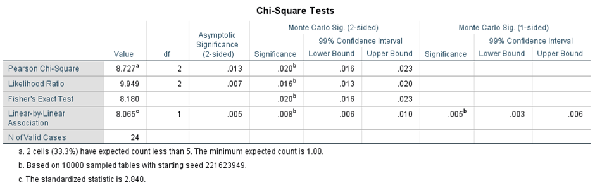

Decision:
Since P-value less than alpha 0.05, we will reject the null hypothesis.
Conclusion:
There is significant difference between two gender and colonies number to each (bacterial growth).

Discussion
Urine culture results of 24 samples show 2 case of signinificat growth, 8 overall no significant growth, and 2 show no growth for (females) ,on the other hand, 9 samples show no growth at all , and 3 show overall no significant growth for (males) , these tell us that the growth of bacteria or number of colonies of bacteria in culture medium were more in females samples than males ,we conclude that the women are have higher risk of Urinary tract infection than men because woman's urethra is shorter than a man's ,so urethral opening close to anal opening therefore bacteria especially E.coli that present as a normal flora in anus ,can move out to the urinary tract causing serious infection ,as well as ladies who have gone through menopause have hormone-related changes to their vagina which could predispose them to infection ,additionally ,if the infection not treated it may move from lower to higher urinary tract to the kidneys ,that may enter via blood stream inflicting septicemia which is sever life-threating condition.

Furthermore, hospitalized patients are at a higher risk of developing UTI due to their age or the presence of an underlying illness such as diabetes, stroke, or urinary tract obstruction. In addition, the majority of UTI in hospitalized patients
are caused by the presence of urinary catheter.

Conclusion
The most common bacteria found to cause urinary tract infections is Escherichia coli because it is present normally in the intestine (to help digestion) and anus, so it can easily move out into the urethra. Besides this, females have a greater than 50% risk of developing UTI than males, mainly due to their anatomical structure or hormonal changes.

Reference

- Urine Culture: How the Test Works. Health line. https://www.healthline.com/health/urine-culture. Published 2022. Accessed June 12, 2022.
- Explained P. Urine culture. Pathologytestsexplained.org.au. https://pathologytestsexplained.org.au/learning/test-index/urine-culture. Published 2022. Accessed June 12, 2022.
- https://www.portea.com/labs/diagnostictests/urine-culture-and-sensitivity-118. Published 2022. Accessed June 12, 2022.
- Urine culture Information | Mount Sinai - New York. Mount Sinai Health System. https://www.mountsinai.org/health-library/tests/urine-culture. Published 2022. Accessed June 12, 2022.
- LEVINSON W. REVIEW OF MEDICAL MICROBIOLOGY AND IMMUNOLOGY. [S.l.]: MCGRAW-HILL EDUCATION; 2022.
- Katzung B. Basic & Clinical Pharmacology. Boston: McGraw Hill; 2007.

