Project Management Workshop
(Assignment) name: mohammed wadi number: 2537
1-Develop a network diagram for the project specified below ?
2-Identify the Critical Activities and the total duration of the project ?
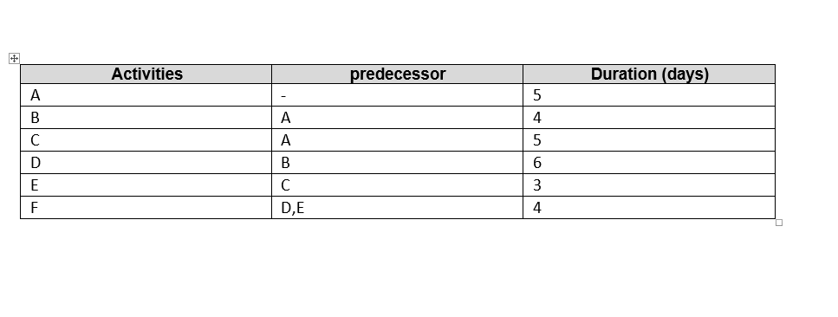
upper (A-B-D-F) critical path = 5+4+6+4=19 days longer duration

D=6 days
B=4 days

F=4 days
A=5 days

E=3 days
C=5 days

lower (A-C-E-F) critical path =5+5+3+4=17 days

3-Justify which activity would you crash based on some rationale ?
The activity would i crash is the lowest (E) one of Days which also mean its the more important one

