

The Libyan International Medical University
Faculty of Applied Medical Science
2nd Medicine (2021-2022)

Laboratory Examination for Urinary Tract Infection

Student Name: Aisha mohamed moussa
Student Number :3002
Date of Submission: 20/6/ 2022

Supervised by: Dr Intissar Naji , Dr Al-senussi sherif ,Dr Naji Al hamery

.

Abstract :
Review of the causes, pathophysiology, classification, and most important therapeutic recommendations for adult urinary tract infections, Urinary tract infections are still a widespread clinical condition that affects sexually active women, pregnant women, the elderly, those who have had their urinary bladder catheterized, and those who have had urological surgery, as well as those who have diabetes or nephrolithiasis. Women are more likely than men to suffer as a result of anatomical disparities. Escherichia coli is the most common etiological factor, but it plays a less role in complicated infections than in non-complicated illnesses. Atypical bacteria, viruses, and fungi may also be responsible for the diseases.,Relapses and reinfections are common aspects of urinary tract infections, and in rare circumstances, long term infections can migrate from the lower urinary tract to the upper

Introduction:
A urinary tract infection is an extremely common condition that occurs in both males and females of all ages. The prevalence and incidence of urinary tract infection are higher in women than in men, which is likely the result of several clinical factors, including anatomic differences, hormonal effects, and behavior pattern , . Although the whole urinary tract may be impacted, infections in the urinary system are frequently defined by the anatomic region or organ implicated. Pyelonephritis is a kidney illness caused by a urinary tract infection. This might be a short-term or long-term problem. Fever, chills, and flank discomfort are all symptoms of acute pyelonephritis. Depending on the severity of the infection and whether there is any restriction to the flow of urine out of the renal collecting system, patients may also feel nausea and vomiting. The risk of renal damage in most patients with an uncomplicated UTI is low, even in those with uncomplicated acute pyelonephritis. Chronic pyelonephritis is characterized by recurrent kidney infections and can lead to renal scarring and reduced function if blockage is present. In extreme instances of pyelonephritis, a perinephric abscess can form The clinical Cystitis is an inflammatory process of the urinary bladder, typically caused by bacterial infection. It may be acute or chronic in nature. Urethritis refers to inflammation or infection of the urethra This is frequently seen in conjunction with cystitis and can be difficult to distinguish., Isolated bacterial urethritis is rare in women. Vaginitis and cervicitis, often related to sexually transmitted organisms, may also because symptoms attributed to cystitis or urethritis. Recurrent urinary tract infections (UTIs) are caused by reinfection from a source outside the urinary system or by bacterial persistence inside it. Infections may be caused by the same or different organisms in each occurrence The vast majority of recurrent UTIs in women are due to reinfection distinction between upper and lower UTI may be difficult, particularly in women.

Materials and methods :

Material: Gloves, a urine sample, a squeezed urine strip, a slide cover, a microscope, a handle, a Bunsen burner, culture, an incubator, a probe for antibiotics
Methods: Patients are asked to collect their first urine in the morning (on awakening) in a clean container. Patients are asked to collect their first urine in the morning (on awakening) in a clean container which does not necessarily need to be sterile. If a patient does not bring his/her urine from home, the urine will be collected in the clinic and then At the time of sampling, the number of cigarettes smoked and the medicines that had been taken from The time the patient woke up will be filled in on a questionnaire, so We started with materials that were provided by Libyan International Medical University: urine sample, urine dipstick, calibrated loop (20 l) and clad agar. With the calibrated loop, we distributed the urine specimen to the center of a nutrient agar plate, and we did a streak across the drop in several planes so that the specimen was distributed evenly across the plate. The plate was incubated at 35°C for 24 hours. After that, we went back to the original urine sample and measured about 2.0 mL in a sterile, empty test tube. Then we put it in (the multipoint inoculator). Finally, we read the plates, counted the cells in each, and reported the number of organisms per milliliter in the urine specimen.

Results and statistical analysis:

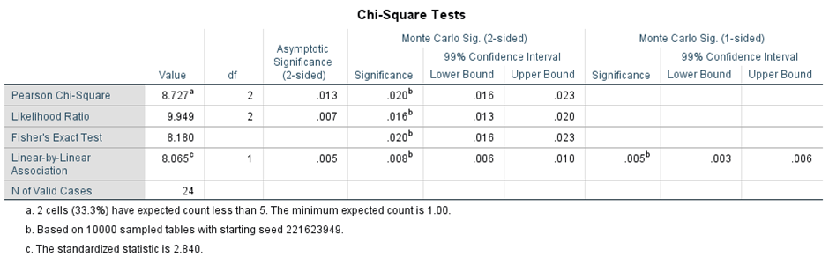

bacterial growth * Gender Cross tabulation
 |  |  | Gender |  | Total
 |  |  | Male | Female | Total
bacterial growth | 1.00 | Count | 9 | 2 | 11
bacterial growth | 1.00 | % within bacterial growth | 81.8% | 18.2% | 100.0%
bacterial growth | 1.00 | % within Gender | 75.0% | 16.7% | 45.8%
bacterial growth | 2.00 | Count | 3 | 8 | 11
bacterial growth | 2.00 | % within bacterial growth | 27.3% | 72.7% | 100.0%
bacterial growth | 2.00 | % within Gender | 25.0% | 66.7% | 45.8%
bacterial growth | 3.00 | Count | 0 | 2 | 2
bacterial growth | 3.00 | % within bacterial growth | 0.0% | 100.0% | 100.0%
bacterial growth | 3.00 | % within Gender | 0.0% | 16.7% | 8.3%
Total |  | Count | 12 | 12 | 24
 |  | % within bacterial growth | 50.0% | 50.0% | 100.0%
 |  | % within Gender | 100.0% | 100.0% | 100.0%

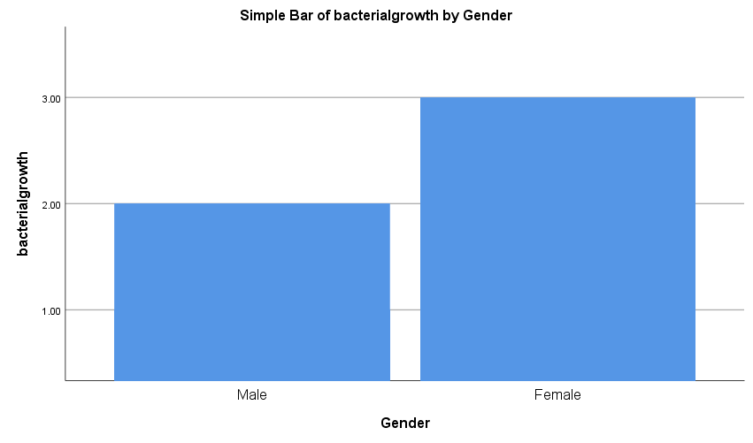

Summary table:
The P-value is set at 0.019. Acceptance to reject the null hypothesis (FTR) Since the null hypothesis P-value is less than alpha 0.05, we accept the null hypothesis. In conclusion, there is an association between gender status and bacterial growth.
A urine transplant was given to 1,594 patients that were being treatment at the time of the study. A urine sample, urinary analysis, or gram spot were not available for 2.9 percent of patients, while 0.1 percent of patients were excluded due to regular catheterization. Of the remaining 1546 patients, 45 percent were girls, with an average age of 3 months. Pathogens were discovered in 12 percent of the patients among the positive culture were 34% of girls and the average age of 3 months was allergies specifically from pyuria 73.2% and 95.1%, respectively, where the gram spot was allergic and specifically 81.4% and 98.2% respectively of 183 positive urine farms, the isolated bacteria were E. coli, klebsiella
.
Discussion:
We assumed that the p value for this was 0.019, so it is possible that the hypothesis could be rejected and conclude that the data is not like this. Contrary to what I expected, the results show that there is no very high incidence of the main bacterial bulb. Wan Wan However, the incidence rate of 16.66% is still lower than what women expect. However, 10 out of 12 women have been presented with bacterial bile, which shows that most women may be at risk of developing a UTI. The incidence rate is 0% in males, with only 8 males showing any development. One growth alone can be considered small, using this information that we have, we have concluded that men are not particularly present or more at risk of developing bacteria, and that women are more susceptible and infected with bacteria, so it is difficult to keep or colonize the male urethra more than the female urethra because it is longer and farther from the anus than the female vagina. Also, if they are more susceptible to bacteria, the risk is still not significant for anxiety, and on average, only 16 out of every 100 women will suffer from a large bacterial infection, and even fewer will suffer from UTI, the risk still exists and is more prevalent among women than among men.13 out of 23 people in both male and female groups have some form of germ cell growth, even if it is not particularly large. A total of 24 urine samples were collected from students for this investigation. Twelve male samples and 12 female samples were taken. There is a significant difference between women and men, and we can conclude that men suffer no harm from this infection when compared to women, and that only eight men have any development and only one growth, which is considered very weak when compared to women, or that there is no comparison at all, and that this rate of 16.66 percent is still considered low and insignificant, and that there is no basis for comparison between the racial groups. Germs have a far harder time colonizing the male urethra than the female one because it is longer and farther from the anus than the female vagina. The source of these urinary tract infections and pyelonephritis is the damaging everyday routine, which is a probable or almost certain reason. And the ASB examination might be essential in identifying any alterations in this type of infection at an early stage. We can also conclude from this experience and statistics that this kind of infection affects both sexes, as well as children and infants of all ages, but that women are more susceptible and common among them, because women's urethras are shorter than men's. Bacteria need only to travel a small distance to infect a woman's bladder. And Lastly, as already mentioned, the most probable microbial organisms that cause these infections

.

Conclusion:
Urinary tract infection (UTI) is a common infectious infection that affects various regions of the urinary tract and is found in both males and females, with E. coli being the most common cause. To treat a UTI, we should first culture the organism and undergo an antibiotic sensitivity test before administering treatment, since this will ensure the patient gets the appropriate antibiotic and avoid antibiotic resistance. So we're using A urinalysis consists of a series of physical, chemical, and microscopic tests performed on a urine sample. These tests look for germs or other signs of infection. This is a test that detects and identifies particular bacteria that may be causing a UTI in a patient's urine. Tests can also assist doctors in determining the optimum antibiotic to use in the treatment of a UTI. Susceptibility testing determines the bacteria's sensitivity to an antibiotic or antifungal medication. Because this helps doctors figure out which treatment is best, a UTI may be classified as "complex" if the patient is a kid, pregnant, or has symptoms that signal the infection has gone beyond the bladder. Patients with a stoppage in urine flow can also get complicated UTIs.

Reference:
- Kanungo R. Levinson W, Jawetz E. Medical Microbiology and Immunology- Examination and Board Review, International Edition (7th)2003, A LANGE Medical Book. The McGraw Hill Companies, Inc. Indian Journal of Medical Microbiology. 2003;21(2):148-149. doi:10.1016/s0255-0857(21)03151-0
- Urinary Tract Infection (UTI) (Male). Pediatric Patient Education. Published online January 1, 2021. doi:10.1542/ppe_schmitt_263
3 Urinary Tract Infection (UTI) (Female). Pediatric Patient Education. Published online January 1, 2021. doi:10.1542/ppe_schmitt_262
4 Urine culture: MedlinePlus Medical Encyclopedia. medlineplus.gov. Accessed May 30, 2020. https://medlineplus.gov/ency/article/003751.htm
5 Urinalysis: MedlinePlus Medical Encyclopedia. Medlineplus.gov. Published 2013. https://medlineplus.gov/ency/article/003579.htm
6 Urinary tract infection - adults: MedlinePlus Medical Encyclopedia. Medlineplus.gov. Published 2015. Accessed April 20, 2019. https://medlineplus.gov/ency/article/000521.htm
7 Dias Neto JA, Martins ACP, Silva LDM da, et al. Community acquired urinary tract infection: etiology and bacterial susceptibility. Acta Cirurgica Brasileira. 2003;18(suppl 5):33-36. doi:10.1590/s0102-86502003001200012

