

The effect of gender on the action of furosemide
Wijdan alawjali -2265-A4
faculty of applied medical sciences –LIMU
3rd year
Supervisor: Dr-Basma.F.Idris

12/06/2022

Abstract
Historically, gender variations in relationships were thought to be limited to dose and efficacy. The goal of this study is to look at the impact of gender on the pharmacodynamics of furosemide (FUR). There are no traditional renal clearance investigations, thus a dose of FUR is needed to achieve the same urine excretion rate in men and women. Males and females excreted sodium, potassium, and water in identical proportions.

Introduction
Urine is the body's natural technique of getting rid of waste liquids. The kidneys, ureter, bladder, and urethra make up the urinary system, which is made up of the kidneys, ureter, bladder, and urethra. There are variances between the male and female urinary systems, despite the fact that they have identical elements: ¹
Male urinary system | Female Urinary System
Connected to the reproductive system | Not connected to the reproductive system
Urethra is 10 to 15 centimeters | Urethra is 3 to 4 centimeters
Transports semen and urine | Transports urine
Passes the prostrate, internal and external sphincters, urogenital diaphragm, Cowper’s gland, and the entire length of the penis | Passes the neck of the bladder, internal and external sphincters, and urogenital diaphragm
Rarely has urinal infections | Urinal infections are common

Information on female pharmacokinetics is available, as is information on putative gender differences in dose-effectiveness connections. In the past, there has been a link between dosages and side effects. It's limited in scope. Few studies have been able to clearly identify clinically relevant ones from a pharmacodynamic standpoint. Loop diuretics prevent salt and chloride from being reabsorbed in Henle's ascending loop. The Na-K-2Cl transporter in Henle's thick ascending loop is blocked to accomplish this. The sigmoid dose-response curve of the loop diuretic has a maximum dose threshold.

Material
A total of 12 patients were given a double dose of furosemide, six of whom were males and six of whom were females. Each of them had their pee production rate measured for 6 hours straight, and the results were as follows:
Subjects urine output (ml)
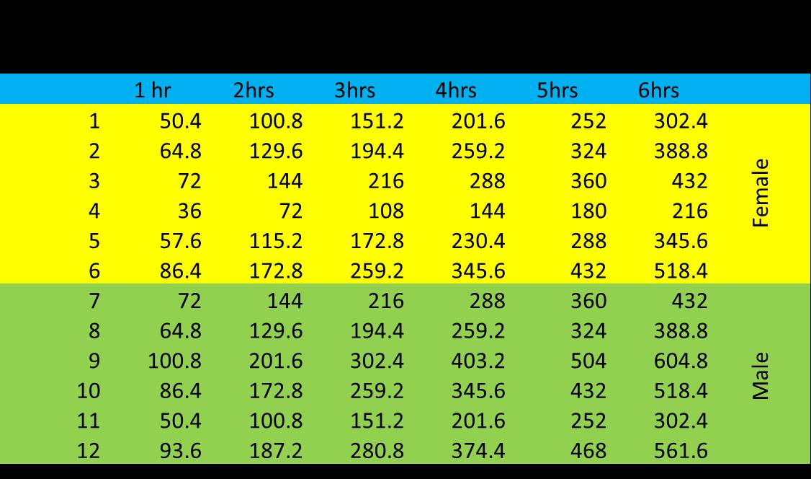
Result
Creating tables and statistics with the spss software. The following has been taken from the source.
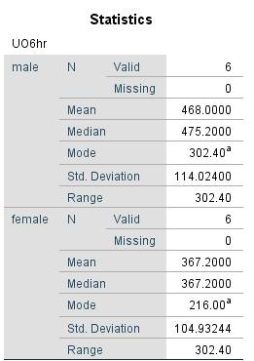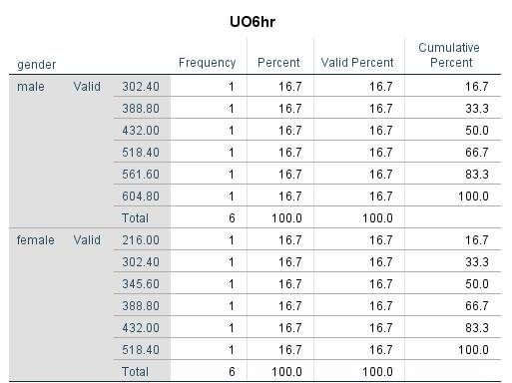
Discussion
According to the first table, there is no statistically significant link between the effect of furosemide and gender differences. As a result, there are no criteria related to how the medicine affects the Na-K-Cl co-transporter in the nephron's thick ascending loop of Henle.
Conclusion
We concluded that males had a greater mean UO (urine output) than females. Males received $468.00, while females received $367.00. Males and females have the same range, which is normal. As a result, these tests do not reveal the rates of diuresis in both sexes, and the medicine has the same mechanism of action in both.

References
1.DIFFERENCE BETWEEN MALE AND FEMALE URINARY SYSTEM. (2015, May 25). Theydiffer. Retrieved May 25, 2015, from https://theydiffer.com/difference-between-male-and-female-urinary-system/
2.Zhang B, Li Q, Shi C, Zhang X. Drug-Induced Pseudoallergy: A Review of the Causes and Mechanisms. Pharmacology. 2018;101(1-2):104-110. doi:10.1159/000479878

