Libyan International Medical University
Faculty of Applied Medical Science
2021-2022

Asymptomatic bacteriuria

Done by: Yasmin Ali Bensadik
Student number: 2838
Supervisor: Intisar Alnaji
Assistant by: Naji Alhoumri

Abstract:
This report will help you understand urinary tract infections and their potential to pose a major risk all over the world, particularly in females. With the acknowledgement of the materials and methods used to detect the microorganism and by counting the colonies > 1 105 CFU/ml and claiming if it is positive or negative and if it is related to asymptomatic bacteriuria, which is a bacterial classis separated into two different urine cultures in a patient who shows no symptoms of urinary tract infection, the cause of this type of infection is not yet fully understood.[1]
Keeping in mind that it is more common in younger females than in younger males [1], and by collecting random samples from students in this report, we discovered that there was 25% no significant growth and 75% no growth according to the male samples, and for the females there were 16.67% of the samples that had significant growth, 16.67% no growth, and 66.67% no significant growth.

Introduction:
Urinary tract infections (UTI) are one of the leading causes of infection worldwide. At the age of 18, at least 10% of females will also have been diagnosed with a UTI.[2] By the age of 24, one out of every three females will be treated for a UTI as it relates to the anatomical structure [2]. Females have a shorter urethra compared to males[1](Figure 1)[1,3]. UTIs are among the most common nosocomial infections, accounting for 35–40% of all hospital-acquired infections. Catheter-associated UTI (CAUTI) is one of the most common nosocomial infections[2], [2] properly accounting for over 1 million cases each year in hospital and nursing home patients. The gold standard test used to determine the causative type of bacteria for a UTI is a urine culture[1,2]. The sterile method is frequently used to compare all collection methods[2]. Even though the urine in the bladder is sterile, contamination of samples can occur as urine passes through the outer third of the urethra[1]. By prevention methods from the contamination like clean catch midstream urine, indwelling catheter, straight catheterization urine and suprapubic bladder aspiration[4]. Gram-positive bacteria, such as Staphylococcus saprophyticus, Enterococcus faecalis, and Streptococcus agalactia, are a common cause of urinary-tract infection (UTI), particularly in the elderly, pregnant women, and those with other risk factors for UTI[5]. Their Escherichia coli, on the other hand, is the most common cause of community urinary tract infection[1]. which is a gram-negative rod[1]. The major symptoms associated with UTI are Strong persistent urges to urinate, pain, frequency with strong smelling and cloudy appearance, and in some cases, the urine can appear in a reddish color, indicating the presence of red blood cells in the urine (hematuria) beside the (pyuria) which is the presence of the white blood cells in the urine and they can indicate some diseases such as pyelonephritis and cystitis[4]. But they don’t appear in asymptomatic bacteriuria until late time.[4]
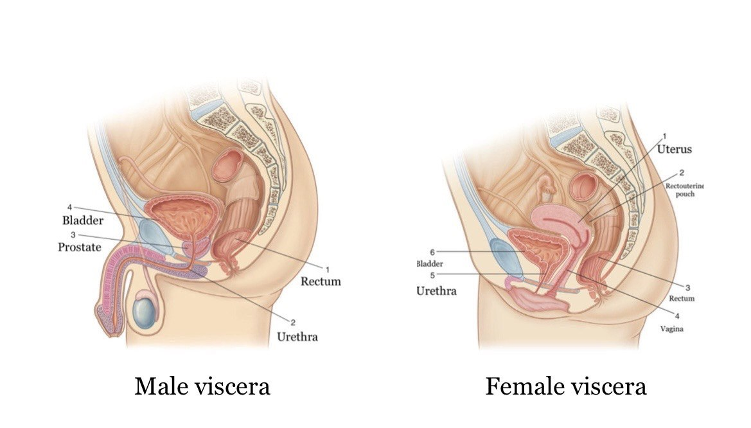
Figure 1 (shows the difference between the male and female urethras length) [3]

Methods and materials
To apply urine culture, we need:
  - Urine sample
  - Wire loop (0.001ml or 0.01ml)
  - Agar plate
  - Flame
  - Incubation
For the steps it begins by:
- Collecting fresh urine from the patient, especially in the morning,
- By applying heat from the flame to the wire loop to sterilize it.
- After that, insert the wire loop vertically into the urine sample to get it attached to the urine (figure 3) [4]
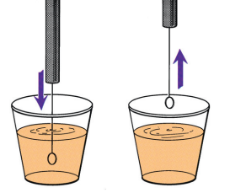
Figure 3(Inserting a calibrated loop into urine to ensure that adequate amount of specimen adheres to the loop) [4]

- The next step is to spread the urine sample on the plate agar by the wire loop.
- Then again, insert the wire loop in the urine sample again without appealing heat to it and transfer it to another plate of agar.
- After that, it will be incubated in air for 24 hours at 37 degrees Celsius.
- Finally, count the colonies that appeared on the plate. The colony forming units (CFUs) are multiplied by 1000 if the wire loop was 0.001 ml or by 100 if the wire loop was 0.01 ml to detect the number of the microorganism per ml in the original specimen.

Results and discussions:
The effect of gender differences on prevalence and microbial spectrum of asymptomatic bacteriuria.
 | No growth | Overall, no significant growth | Significance growth
Males | 9 | 3 | 0
Females | 2 | 8 | 2
Table 1
According to the (table1), it shows the samples that were obtained from the students. In total, there were 12 females and 12 males. application of the chi-square test on the statistical side to figure out if the results were significant or not, because the samples were randomly obtained from the students, they are qualitative variables, and if they support the null hypothesis, which is that there is no association between the 2 variables, or alternative hypothesis that conforms to the association between the 2 variables,
As for the assumptions, it depends on the independence of the sample, if the sample is randomly selected, and the sample size.

Chi-Square Tests
 | Value | df | Asymptotic Significance (2-sided)
Pearson Chi-Square | 8.727ª | 2 | .013
Likelihood Ratio | 9.949 | 2 | .007
Linear-by-Linear Association | 8.065 | 1 | .005
N of Valid Cases | 24
a. 2 cells (33.3%) have expected count less than 5. The minimum expected count is 1.00.

CFUcat * Gender Crosstabulation
 |  |  | Gender |  | Total
 |  |  | Female | Male | Total
CFUcat | No growth | Count | 2 | 9 | 11
CFUcat | No growth | Expected Count | 5.5 | 5.5 | 11.0
CFUcat | No growth | % Within Gender | 16.7% | 75.0% | 45.8%
CFUcat | Overall, no significant growth | Count | 8 | 3 | 11
CFUcat | Overall, no significant growth | Expected Count | 5.5 | 5.5 | 11.0
CFUcat | Overall, no significant growth | % Within Gender | 66.7% | 25.0% | 45.8%
CFUcat | Significant growth | Count | 2 | 0 | 2
CFUcat | Significant growth | Expected Count | 1.0 | 1.0 | 2.0
CFUcat | Significant growth | % Within Gender | 16.7% | 0.0% | 8.3%
Total |  | Count | 12 | 12 | 24
 |  | Expected Count | 12.0 | 12.0 | 24.0
 |  | % Within Gender | 100.0% | 100.0% | 100.0%

Case Processing Summary
 | Cases
 | Valid |  | Missing |  | Total
 | N | Percent | N | Percent | N | Percent
CFUcat * Gender | 24 | 64.9% | 13 | 35.1% | 37 | 100.0%

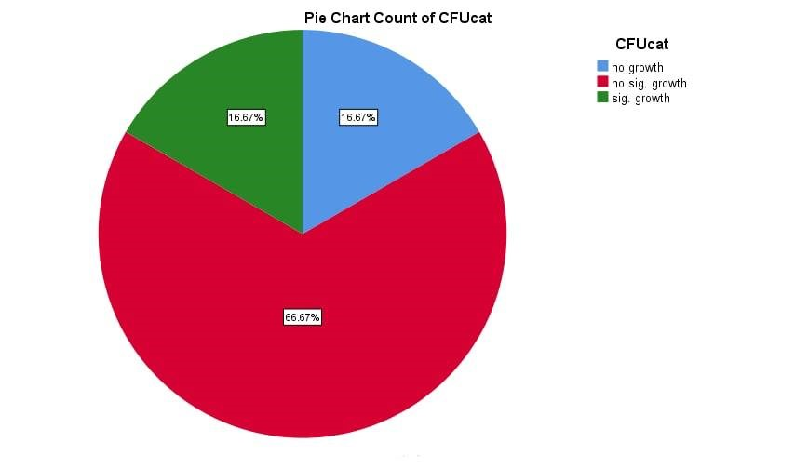figure 3(pie chart for the female's sample)
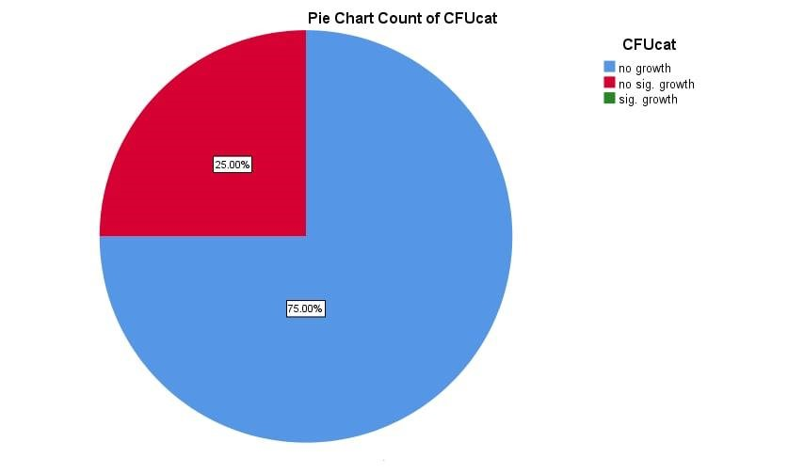 figure 4(pie chart for the male's sample)

- The results showed that the females' samples were exposed to more significant growth than males. In total, the significant growth was 16.67%, which is 2 of the samples; 16.67% no growth at all, which counts 2 of the samples; and 67.67% for no significance growth, which counts 8 as it was shown in (figure 3).
- On the other hand, the male samples were not exposed to the growth and their results were 25% for no significant growth, which counts 3 of the samples, and 75% for no growth, which was 9 as shown in (figure 4).

- Based on this finding, we can conclude that females are more vulnerable to urinary tract infections than males, as mentioned previously.
- Since the p value is 0.013 and 0.05, we can reject the null hypothesis and there is an association between the 2 variables.
Conclusion:
  - The result revealed that the females have higher exposure to the UTIs
  - The application of the chi square approved this idea, and there is an association between the 2 variables.
  - Until now, there have been no predictions to lower the incidence of urinary tract infection among females except for prophylactic methods and treatment.

References: for further reading
- [1] Levinson W, York N, San C, Athens F, Madrid L. Medical Microbiology and Immunology Review of 2016.
- [2] Sinawe H, Casadesus D. Urine Culture. 2022.
- [3] Drake FAAA RL, Wayne Vogl FAAA A, Mitchell MB BS FRCS FRCR AW. Gray’s Anatomy for Students Flash Cards: with STUDENT CONSULT Online Access. 2015.
- [4] Taxonomy M. Bailey & Scott’s Diagnostic Microbiology. 2014.
- [5] Kline KA, Lewis AL. Gram-Positive Uropathogens, Polymicrobial Urinary Tract Infection, and the Emerging Microbiota of the Urinary Tract. Microbiol Spectr 2016;4. https://doi.org/10.1128/microbiolspec.UTI-0012-2012.

