

Difference Between Adult Male And Female In Urine Output
After Lasix Consumption

Libyan international medical university
Faculty of medicine
Student Name: Nada Mohammed Salem
Student Number: 2496
Group: A3

Hypothesis
Urine output is higher in an adult male than an adult female after consumption of lasix
Abstract
Gender differences in drug dose and efficacy are a possibility. The purpose of this study was to see how sex affects the efficacy of furosemide (FUR) in both men and women. Male and female sodium, potassium, and water fractional excretions were similar, Urine samples were used for 12 participants (6 females and 6 males) after they were given 40 mg furosemide (Lasix),The urinary excretion rate of furosemide and sodium and cumulative urine excretion rate was not different between the oral and sublingual administration of furosemide ,There was no statistically significant difference found between male and female subjects with respect to urine flow rate, sodium, and potassium excretion rates among the treatments
Introduction
Urine is mostly water, with inorganic salts and soluble metabolic wastes making up the rest; urobilin and other colored hemoglobin breakdown products give urine its distinctive hue, In a 24-hour period, the usual range is 800 to 2,000 milliliters (with a normal fluid intake of about 2 liters per day).¹
Females have a higher urine rate than males in typical circumstances because they drink more water, the volume of urine that is considered "normal" is determined by your age and gender, Less than 2 liters per day, on the other hand, is usually regarded normal.¹
By blocking the sodium-chloride cotransport system, furosemide limits tubular reabsorption of sodium and chloride in the proximal and distal tubules, as well as the thick ascending loop of Henle, leading in increased output of water, sodium, chloride, magnesium, and calcium.²
The commencement of action of furosemide normally occurs within the first hour of oral furosemide consumption, and the maximal effect occurs within the first 1 to 2 hours. When compared to the bioavailability of furosemide given intravenously, oral furosemide has a 51 percent bioavailability.²
Bioavailability: In patients with edema, particularly in those with decompensated heart failure, furosemide absorption is slower than normal nonetheless, the amount of loop diuretic absorbed is normal.²
The oral form of furosemide administration achieves a peak concentration slower than the intravenous route
Furosemide glucuronide, a significant bio-transformation active product with an active diuretic action, is a major bio-transformation active product of furosemide, There is no difference in the amount of unaltered furosemide excretion in urine between the two formulations, according to recent studies, Furosemide is slightly processed in the liver and is eliminated in the urine following IV treatment.²
Materials and methods
Urine samples were used for 12 participants (6 females and 6 males) after they were given 40 mg furosemide (Lasix), and urine samples were obtained every hour for the next 6 hours for each of them.
Urine output was calculated using the following equation: Urine Output= (quantity of urine / number of hours) / patient's weight in kg.
The (P < 0.05) was considered significant statistically and if it was (p > 0.05) considered not significant statistically.

Urine output (6hr) | gender | subject
302.4ml | male | 1
388.8ml | male | 2
432ml | male | 3
216ml | male | 4
345.6ml | male | 5
518.4ml | male | 6
432ml | female | 7
388.8ml | female | 8
604.8ml | female | 9
518.4ml | female | 10
302.4ml | female | 11
561.6ml | female | 12

Results and Statistical Analysis
After we used the statistical application of our data to show the diuresis of males and females, and our data are six males and six females after they took 40 mg furosemide (Lasix)
We used the test( independent samples T test) to show the difference between the diuresis of males and females after taking this drug, and it became clear to us in this statistic that there is no difference( null hypothesis ) in urine production between males and females,
Because the P value = .142(>0.05) was found in my data after applying of this test.

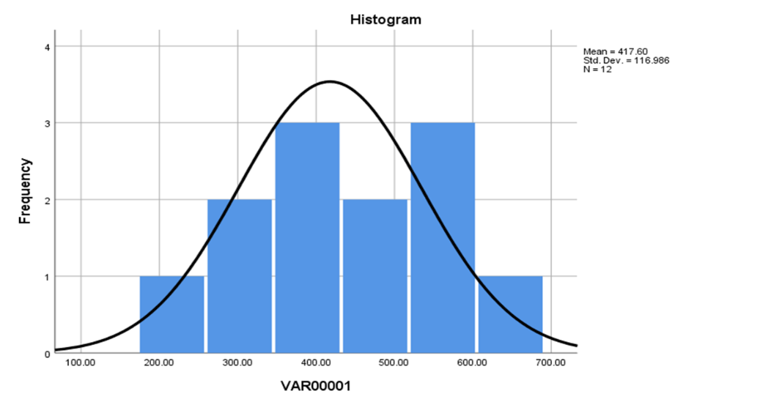
Fig. 1.

Discussion
After we took urine samples from males and females, calculated them after six hours, and worked on the same statistics, what became clear to the result, the first picture and us is that there is no difference.
The difference between the urinary system in males and females is that the length of the urethra is longer in males because it extends to the penis, and this does not mean that urination is more in male's gender, knowing that the urine samples that the statistics worked on were few, If they were more, he could very well confirm the result.
In comparison to the previous study, it states: Total urine output was collected for volume measurement and evaluation of salt and potassium values during the next 24 hours, There was no statistically significant difference in urine flow rate, salt, or potassium excretion rates between male and female subjects between the treatments, Male subjects had a higher peak sodium excretion rate than female subjects when the natriuretic response was adjusted for mg/kg of intravenous furosemide dose administered The findings of this study show that the natriuretic response to diuretics differs depending on gender, To ascertain whether the gender discrepancy is related to differences in drug metabolism.³
More research is needed on disposition or intrinsic diuretic responsiveness at the site of actions.
The amount of unmodified furosemide discharged in urine after IV therapy does not change between the two forms, Concentrations and excretion Plasma furosemide concentrations, urine excretion rates, and renal function were all compared to diuresis/salutes.
When observed diuresis/salutes were compared to plasma furosemide concentrations, urine excretion rates, and renal clearance, clearance was found negative or no connections with plasma drug concentrations, but substantial associations with urine measurement
However, more furosemide is eliminated The amount of unmodified furosemide discharged in urine after IV therapy does not change between the two forms.²
After intravenous administration, furosemide achieves a high peak serum concentration and a rapid peak excretion rate, Following parenteral treatment, a higher amount of furosemide is eliminated in urine than after oral administration.²
Conclusion
After receiving 40 mg furosemide, urine samples were taken from 6 females and 6 males (Lasix) ,There is no difference in the amount of urine produced by males and females
The urethra in males is longer because it extends to the penis, but the urethra in females is shorter because it does not extend to the penis After IV delivery, furosemide is eliminated in the urine; there is no difference in the amount of unaltered furosemide excretion in urine between the two formulations When the natriuretic response was corrected for mg/kg of intravenous furosemide dose given, male individuals showed a higher peak sodium excretion rate than female subjects. The results of this research reveal that the natriuretic response to diuretics varies by gender.

Referencing
1-Arthur C. Guyton; John Edward Hall (2006). "25". Textbook of medical physiology (11 ed.). Elsevier Saunders. ISBN 978-0-8089-2317-6. Archived from the original on 26 May 2013. Retrieved 26 September 2011
2-Furosemide - StatPearls - NCBI Bookshelf. (n.d.). Retrieved June 7, 2022, from https://www.ncbi.nlm.nih.gov/books/NBK499921/
3-AH;, F. K. L. K. J. M. L. N. P. L. (n.d.). Gender effect on diuretic response to hydrochlorothiazide and furosemide. International journal of clinical pharmacology and therapeutics. Retrieved June 7, 2022, from https://pubmed.ncbi.nlm.nih.gov/8705087/

