


Libyan International Medical University
Faculty of Applied Medical Science

The incidence rate of Asymptomatic Bacteriuria among LIMU students

Student Name: Rawan Wael Alsadawi
Student Number: 2326
Supervisor: Dr.Khadija Muftah Mansour
Assistant: Dr.Ahmed aljaybany

Abstract

Urinalysis measurements were collected from 30 men and 33 women. The presence of microorganisms was determined in urine samples grown on CLED. The most common bacteria associated with asymptomatic bacteriuria is Escherichia coli (ABU). In contrast to uropathogenic E. coli, which causes symptomatic urinary tract infections (UTI), asymptomatic bacteriuria is defined as a high bacterial count in the urine but no symptoms of a UTI (UTI). Mid-stream urine samples were tested for significant asymptomatic bacteriuria using standard bacteriological methods. Females are more susceptible to bacteria than males. There was a statistically significant difference in asymptomatic bacteriuria with gender (X2, P=0.004).

- Introduction
Symptomatic UTI is characterized by bacteriuria that causes symptoms in the urinary tract. It can be upper (pyelonephritis) or lower (cystitis), with the former, causing flank discomfort and renal angle tenderness, and the latter causing dysuria, frequency, and urgency of micturition. Furthermore, UTIs can be classified into two types: complex and uncomplicated. A complex UTI arises when a person's urinary system is aberrant or their susceptibility to infection is enhanced. This includes men and people with catheters or diabetes (due to the frequent association with prostatic enlargement). A bacteremia UTI occurs when the same organism is found in both the blood and the urine at the same time.¹

The high prevalence of asymptomatic bacteriuria (ASB), or the presence of bacteria in the urine of people who have no symptoms, is one of the biggest challenges in diagnosing UTIs. ASB is uncommon in younger people, although it is prevalent in 7–10% of men and 17–20% of women over the age of 75, as well as 40–50% of non-catheterized adults in care facilities.
Bacteriuria affects all long-term catheter users. ASB is linked to the presence of white blood cells (WBC) in the urine (pyuria). A patient with ASB who presents with symptoms unrelated to the urinary tract may be wrongly labeled as having a "confirmed UTI," perpetuating the misconception of UTIs as a common cause of infection.²

Escherichia coli is the most frequent organism remoted from sufferers with asymptomatic bacteriuria. Infecting organisms are numerous and encompass Enterobacteriaceae, Pseudomonas aeruginosa, Enterococcus species, and group B streptococcus. Organisms isolated in patients with asymptomatic bacteriuria will be influenced by affected person variables: healthful persons will possibly have E.coli, whereas a nursing domestic resident with a catheter is more likely to have multi-drug–resistant polymicrobial flora (e.g. aeruginosa). Enterococcus species and gram-negative bacilli are common in men.³

The use of antibiotics is associated with the resistance to commonly used antibiotics, especially amoxicillin and trimethoprim are rising, and Complicated UTIs are usually best initially treated with a broad-spectrum antibiotic. If antibiotic sensitivities subsequently show a narrow-spectrum agent is appropriate, consideration should be given to changing medication to limit the risk of hospital-acquired infection.⁴.⁵ the purpose of this present research is to evaluate the prevalence of asymptomatic Bacteriuria among LIMU students.

Literature Review

Research referred to argue that Tran’s abdominal bladder aspirate gives more reliable results .⁶ another study reported that there is another reason for this high incidence maybe since those studied belonged to the low/middle socioeconomic group. The socio-economic level has been reported to have an effect on the prevalence of bacteria in a pregnant population.⁷ additionally, research reported that bacteriuria is more common in females and is often asymptomatic with frequent reoccurrence.⁸

- Materials

An average of 63 participants were involved in this study, both men and women were examined for asymptomatic bacteriuria. The majority of the participants are female (33 female) whereas (30 men) are participating in this study. Both genders were provided with the opportunity prior to sample collection. Data management and statistical analyses were conducted in the SPSS version software program therefore the test used in the calculating data is chi-square.

- physical examination

In investigating the urine sample it is noted that the urine from the patient is usually clear and cloudy, but an unusual odor may suggest a problem, such as an infection. Blood in the urine might cause it to appear red or brown. The color of urine can be seen.
- Chemical examinations

A dipstick test examines for Acidity (pH) Concentration, blood, and Sugar. Strips of chemicals are inserted in the urine for minutes to determine if there are any anomalies. The chemical strips change color when compared to the reference range at the bottle.

- Microscopic examinations

A microscope is used to examine urine. If any of the following are observed: white blood cells, red blood cells, bacteria, or yeasts cast crystals at the beginning of good serialization of the loop by using Benson burner and then allowing it to cool for a few seconds. Prepared a cutler medium and dropped little drops of urine into it.

- Results and Statistical analysis
Of a total of 24 LIMU students, 50% (12/24) were females and 50% (12/24) were males (Figure 1). The overall prevalence of asymptomatic bacteriuria among LIMU students was 54.2 %( 13/24) (Figure 2).

Figure 1: Gender among LIMU students

Figure 2: Prevalence of asymptomatic bacteriuria among LIMU students.

The median number of colonies of bacteria in the urine growth was 10000 ranging from 0 to 100000 CFU/ml, 25% of students had 100 colonies Urine cultures were considered positive if they showed any growth of 10,000 CFU/mL or more. There were 7(29.2%) students with urine samples that grew less than 10,000 CFU/mL, 6(25%) cases with 10,000 CFU/ml and more and 11(45.8%) had no growth (Figure 3). So, the prevalence of asymptomatic bacteriuria among LIMU pupils was 18(75%) and 6(25%) (Figure 4).
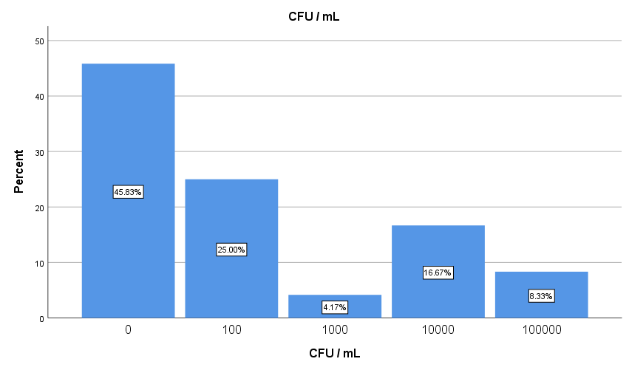

Figure 3: The percentages of LIMU students with and without a urinary tract infection (UTI) in colony-forming units per milliliter for reporting urine culture results.

Figure 4: The prevalence of asymptomatic bacteriuria among LIMU student

The prevalence of asymptomatic bacteriuria in females was 41% (10/ 24) in LIMU students while 12.5% (3/24) in apparently in males. A high prevalence of asymptomatic bacteriuria was observed in females as compared to males. There were statistically significant differences in asymptomatic bacteriuria with gender (X^{2,} P=0.004) (Table 5).

Table 5: The association between bacteriuria growth and gender.

Gender | Bacteriuria growth |  | X² | P-value
Gender | Yes  No (%) | No  No (%) | X² | P-value
Gender | Yes  No (%) | No  No (%) | 8.224 | 0.004
Female | 10(41) | 2(8.3) | 8.224 | 0.004
Male | 3(12.5) | 9(37.5) | 8.224 | 0.004

- Discussion
The proportion of substantial bacteriuria in the studied sample was 24 participants, and the result indicates a significant increase in three females and none males. Furthermore, E. coli, one of the most common gram-negative isolates in CLED agar, was the most costive of asymptomatic bacteria. (Table 5)
This study was carried out to determine the presence of asymptomatic bacteriuria among 24 LIMU students. Prevalence of asymptomatic bacteriuria was observed in 10% of the population. However asymptomatic bacteriuria does not cause symptomatic urinary tract infections in the majority of patients, and therefore has no negative repercussions, asymptomatic bacteriuria does not cause symptomatic urinary tract infections in the majority of patients, and therefore has no negative repercussions. Antibiotic treatment for asymptomatic bacteriuria does not benefit children, diabetic patients, the elderly, patients with spinal cord injuries, or patients with indwelling urinary catheters. Treatment does not increase survival or reduce the prevalence of symptomatic urinary tract infections in these patients.
Asymptomatic bacteriuria is 2 to 3 times more common in women with diabetes than in women without diabetes.
Urinalysis (UA) is valuable in allowing clinicians to make a presumptive diagnosis of urinary tract infection (UTI) and initiate appropriate empirical antimicrobial treatment Urine is normally sterile. However, in the process of collecting the urine, some contamination from skin bacteria is frequent. For that reason, the Enumeration of individual colonies in a bacterial culture. Up to 10,000 colonies of bacteria/ml are considered normal. Greater than 100,000 colonies/ml represents urinary tract infection. For counts between 10,000 and 100,000, the culture is indeterminate.
Healthy adults are more likely to have E. coli, whereas nursing home residents with catheters are more likely to have multidrug-resistant polymicrobial flora. Enterococcus species and gram-negative bacilli are more common in men than in women the results of urine culture and sensitivity should guide treatment. Amoxicillin, amoxicillin/clavulanate, cefuroxime, cephalexin, and nitrofurantoin are all safe antibiotics to take. The treatment will last one week and have at least one more urine culture conducted.

- Conclusion

The technique used to evaluate ASBU Asymptomatic bacteriuria, the result shows it is more common among female LIMU university students than males, there were statistically significant differences in asymptomatic bacteriuria with gender while E. coli is the most common causal pathogen leading to asymptomatic bacteriuria. Good cleanliness should be encouraged, however, self-prescription of antibiotics should be minimized because it can contribute to antibiotic resistance.

References
- Ducharme, J., Neilson, S. and Ginn, J., 2007. Can urine cultures and reagent test strips be used to diagnose urinary tract infection in elderly emergency department patients without focal urinary symptoms? CJEM, 9(02), pp.87-92.

- Baldassarre, J. and Kaye, D., 1991. Special Problems of Urinary Tract Infection in the Elderly. Medical Clinics of North America, 75(2), pp.375-390.

- Abrutyn E, Mossey J, Levison M, Boscia J, Pitsakis P, Kaye D. Epidemiology of Asymptomatic Bacteriuria in Elderly Women. Journal of the American Geriatrics Society. 1991;39(4):388-393.
- BARKHAM, T., MARTIN, F. and EYKYN, S., 1996. Delay in the Diagnosis of Bacteraemic Urinary Tract Infection in Elderly Patients. Age and Ageing, 25(2), pp.130-132.
- Akpa M, Emem-Chioma P, Odia O. Current epidemiology of hypertension in Port Harcourt metropolis, Rivers State, Nigeria. Port Harcourt Medical Journal. 2008;2(3).

- Köhler, W., 1975. E. H. Lennette, E. H. Spaulding and J. P. Truant (Editors), Manual of Clinical Microbiology (2nd Edition). 970 S., 241 Abb., 189 Tab., 1 Tafel. Washington 1974: American Society for Microbiology. $ 15.00. Zeitschrift für allgemeine Mikrobiologie, 15(4), pp.303-303.

- Turck, M., Goffe, B. and Petersdorf, R., 1962. Bacteriuria of Pregnancy. New England Journal of Medicine, 266(17), pp.857-860.

- Modarres, S. and Oskoii, N., 1997. Bacterial etiologic agents of urinary tract infection in children in the Islamic Republic of Iran. Eastern Mediterranean Health Journal, 3(2), pp.290-295.

