

Libyan International Medical University
Faculty of AMS
nd Medicine (2021-2022)2

The incidence rate of Asymptomatic Bacteriuria among LIMU students
Urinary tract infection test))
Name : Rodina Nasser Gorman
Student number : 2179
lab report Supervisor's : Dr.Intisar Alnagi
Assistant by :Dr.Asma Elkwafi
Laboratory technicians supervisors: Lougin Shakmak

Date of Submission: 20…/…6…/ 2022

Abstract
Background Asymptomatic bacteriuria is the presence of actively multiplying bacteria within the urinary tract in the absence of any symptoms. Anatomical and physiological changes make women more susceptible to UTI
Aims and objectives :this study was carried out to determine the incident rate of Asymptomatic bacteriuria among LIMU
Method : A total 24 participant 2 group (12 female ) and (12 male) aim of this study to take sample from urine to show the incident rate of asymptomatic bacteriuria among LUMU
asymptomatic bacteriuria is presence of bacteria in the properly collected urine of a patient that has no signs or symptom of UTI
is very common in clinical practice and its incidence increases with age
Results : significant bacteriuria was noted total number of females it including

Introduction
Urinary tract infections are amongst the most common infections encountered in clinical practice . About 50% of women experience at least one episode of urinary tract infection during their life time. 1
UTI in pregnancy can be symptomatic or asymptomatic.1-4 Asymptomatic bacteriuria (ASB) is defined as persistently and actively multiplying bacteria in significant numbers i.e., 5 bacteria per ml within the urinary tract without any obvious symptoms.1-5 It is also known as Covert bacteriuria. Females are more susceptible for these infections because of the short length of urethra along with proximity to warm, moist anal canal.4 Sexual intercourse facilitate the ascent of bacteria into bladder. The pregnant females are two times more commonly affected than age matched non-pregnant females. The reason behind this is urinary stasis due to progesterone effect in pregnancy in addition to different anatomical changes occurring during pregnancy.2,4Various studies from the west have documented the prevalence of asymptomatic bacteriuria in pregnancy to be between 2 and 7% while in India it was found to be on higher side i.e., between 5 and 17%.6-10 Studies in African region showed higher prevalence than both these regions.11 Commonest organisms responsible are Escherichia coli (80–85%), followed by coagulase negative Staphylococcus species, Klebsiella species, Pseudomonas species, and Proteus species.6-11
The Gold standard investigation for detection of asymptomatic bacteriuria is urine culture aim of this study to take sample from urine to show the incident rate of asymptomatic bacteriuria among LUMU.
Materia and method

This screened Descriptive study include 24 participants were split into 2 group (group B 12 male) and ( group A 12 female )
asymptomatic bacteriuria is presence of bacteria in the properly collected urine of a patient that has no signs or symptom of UTI is very common in clinical practice and its incidence increases with age

material
inoculating urine sample into the culture media and put it in the incubator for 24hr , in this antibiotic sensitivity test we use six type of antibiotic
the antibiotic
1- IPM : imipenem 2-APX: ampicillin 3-CXM: ceprofixacin
4-DA: clindamycin 5-PB: polymyxin 6-AX: ampicillin
- need investigation before prescribed antibiotics
investigaton routine analysis (RBC) special analysis,(when RBC elevated and to know if bacteria recurrent), X-ray and abdominal ultrasound
Serum creatinine , Antibiotic sensitivity ,testModulation of PH
To enhance the activity of antibiotic , prevent crystal urea , suppress microorganism growth , relieve Dysuria

result and discussion
A total 24 of participants were screened result of sample take from both male and female .The result of females show 16.7% no bacteria growth, The result of males show 75% no bacteria growth .as shown in ( Table1)

Table 1: The association between bacteriuria growth and gender
Male (%) | Female (%)
9(75%) | 2(16.7%) | No growth
3(25%) | 8(66.7%) | No significant growth
0(0%) | 2(16.7%) | Significant growth
P – value 0.018

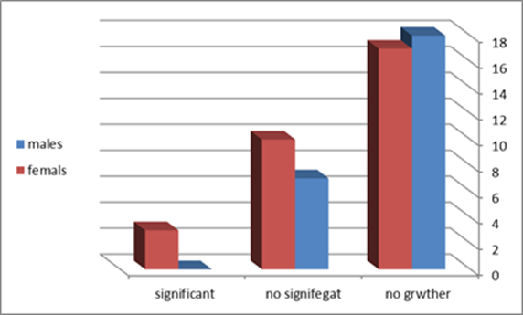

Table 2: The Chi-Square Tests of bacteriuria growth and gender

Chi-Square Tests
 | Value | df | Asymptotic Significance (2-sided) | Monte Carlo Sig. (2-sided) |  |  | Monte Carlo Sig. (1-sided)
 |  |  |  | Significance | 99% Confidence Interval |  | Significance | 99% Confidence Interval
 |  |  |  |  | Lower Bound | Upper Bound | Significance | Lower Bound | Upper Bound
Pearson Chi-Square | 8.727ª | 2 | .013 | .018^{b} | .014 | .021
Likelihood Ratio | 9.949 | 2 | .007 | .012^{b} | .009 | .015
Fisher's Exact Test | 8.180 |  |  | .018^{b} | .014 | .021
Linear-by-Linear Association | 8.065^{c} | 1 | .005 | .006^{b} | .004 | .008 | .002^{b} | .001 | .003
N of Valid Cases | 24
a. 2 cells (33.3%) have expected count less than 5. The minimum expected count is 1.00.
b. Based on 10000 sampled tables with starting seed 2000000.
c. The standardized statistic is 2.840.

CFUcat * Gender Crosstabulation
 |  |  | Gender |  | Total
 |  |  | Male | Female | Total
CFUcat | no growth | Count | 9 | 2 | 11
CFUcat | no growth | Expected Count | 5.5 | 5.5 | 11.0
CFUcat | no growth | % within CFUcat | 81.8% | 18.2% | 100.0%
CFUcat | no growth | % within Gender | 75.0% | 16.7% | 45.8%
CFUcat | non sig growth | Count | 3 | 8 | 11
CFUcat | non sig growth | Expected Count | 5.5 | 5.5 | 11.0
CFUcat | non sig growth | % within CFUcat | 27.3% | 72.7% | 100.0%
CFUcat | non sig growth | % within Gender | 25.0% | 66.7% | 45.8%
CFUcat | sig growth | Count | 0 | 2 | 2
CFUcat | sig growth | Expected Count | 1.0 | 1.0 | 2.0
CFUcat | sig growth | % within CFUcat | 0.0% | 100.0% | 100.0%
CFUcat | sig growth | % within Gender | 0.0% | 16.7% | 8.3%
Total |  | Count | 12 | 12 | 24
 |  | Expected Count | 12.0 | 12.0 | 24.0
 |  | % within CFUcat | 50.0% | 50.0% | 100.0%
 |  | % within Gender | 100.0% | 100.0% | 100.0%

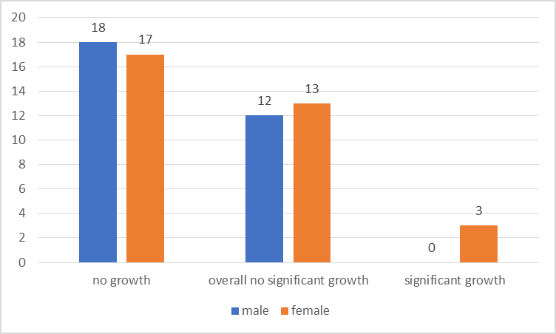
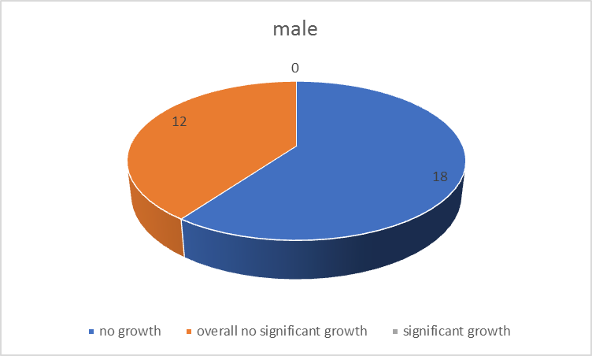
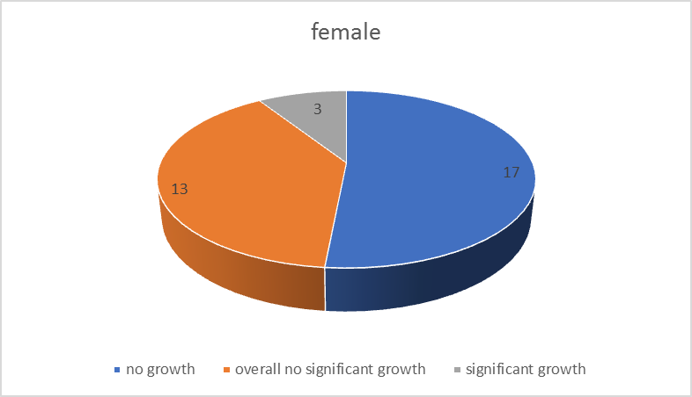
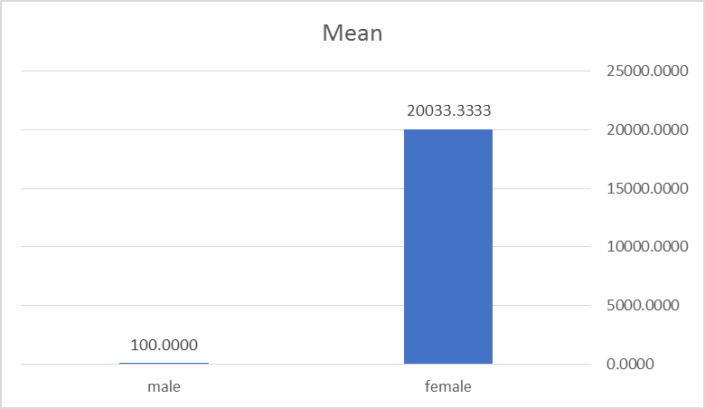
The majority of patients with ASB and/or asymptomatic pyuria SHOULD NOT be treated.
Studies have demonstrated that treatment of ASB does not prevent urinary tract infections (UTIs), but is associated with adverse events related to antibiotic use and the development of future UTIs that are antibiotic resistant.
Exceptions Pregnant patients: treatment prevents preterm labor and pyelonephritis. Patients about to undergo a urologic procedure in which mucosal bleeding is expected (not urinary catheter placement): treatment prevents urosepsis.
How can I prevent unnecessary treatment of asymptomatic bacteriuria?
Do not order urine cultures unless your patient has signs and symptoms of a UTI, including in patients undergoing preoperative evaluation or patients with urinary catheters (except in pregnant patients or those about to undergo a urologic procedure in which mucosal bleeding is expected).
Note:
o Foul-smelling or cloudy urine does not indicate a UTI.
o Delirium, insomnia, and falls alone do not indicate a UTI

all sample were collected during urological examination at room temperature and immediately taken to the laboratory under refrigerated conditions all urine samples were analyzed for cultures
in the lab microbiology section
that is no growth in blood agar and macCKonKey agar is mean no bacteria in urine
the result : All of the this antibiotic are resistances to E.coli except polymyxin and imipenem
pharmacology section
need investigation before prescribed antibiotics investigation routine analysis (RBC) ,special analysis(when RBC elevated and to know if bacteria recurrent ) ,X-ray and abdominal ultrasound ,Serum creatinine Antibiotic sensitivity test.

CONCLUSION
Asymptomatic bacteriuria could be detected by urine screening program. Screening for asymptomatic bacteriuria helps to know the prevalence. with predominance in females .In asymptomatic bacteriuria, large numbers of bacteria are present in the urine. However, the person has no symptoms of a urinary tract infection (asymptomatic means without symptoms). It is not clear why the bacteria don't cause symptoms. It may be that asymptomatic bacteriuria is caused by weaker (less "virulent") bacteria. The condition does not always need to be treated.

REFERENCES

1. Leslie C, Albert B, Max S. Topley and Wilson's microbiology and microbial infections. 10th ed. London: Edward Arnold. 1998;3.
2. Cunningham FG, Gant NF, Laveno KJ. Renal and urinary tract disorders. Williams Obstetrics. 24thEd. New York: McGraw-Hill Medical Publishing Division; 2014:1052-56.
3. Forbes BA, Sahm DF, Weissfeld AS. Infections of urinary tract. Bailey and Scott's Diagnostic microbiology. 12th ed. Missouri: Mosby Elsevier. 2007:842-54.
4. Mandell GL, Bennett JE, Dolin R. Urinary tract infections. Mandell, Douglas, and Bennett's principles and practice of infectious diseases. 7th ed; 2009:957-976.
5. Anantnarayanan R, Ananthanarayanan PJ, Kapil A. Paniker’s text book of microbiology. 9th Ed; 2013:277-280.
6. Imade PE, Izekor PE, Eghafona NO, Enabulele OI, Ophori E. Asymptomatic bacteriuria among pregnant women. N Am J Med Sci. 2010;2(6):263-6.
7. Colgan R, Nicolle LE, Mcglone A, Thomas M. Hooton. Asymptomatic bacteriuria in adults. Am Family Physician. 2006;74(6):985-90.
8. Chandel LR, Kanga A, Thakkur K, Mokta KK, Sood A, Chauhan S. Prevalance of pregnancy associated asymptomatic bacteriuria: a study done in a tertiary care hospital. J Obstet Gynaecol India. 2012;62(5):511-
9. Lavanya SV, Jogalakshmi D. Asymptomatic bacteriuria in antenatal women. Indian J Med Microbiol. 2002; 20(2):105-6.
10. Jain V, Das V, Agarwal A, Pandey A. Asymptomatic bacteriuria and obstetric outcome following treatment in early versus late pregnancy in north Indian women. Indian J Med Res. 2013;137(4):753-8.
11. Demilie T, Beyene G, Melaku S, Tsegaye W. Urinary bacterial profile and antibiotic susceptibility pattern among pregnant women in north west ethiopia. Ethiop J Health Sci. 2012;22(2):121-8.

