Project management assignment
Rodina Hani Albasser 2597
1-Develop a network diagram for the project specified below. (50 %)
2-Identify the Critical Activities and the total duration of the project. (35%)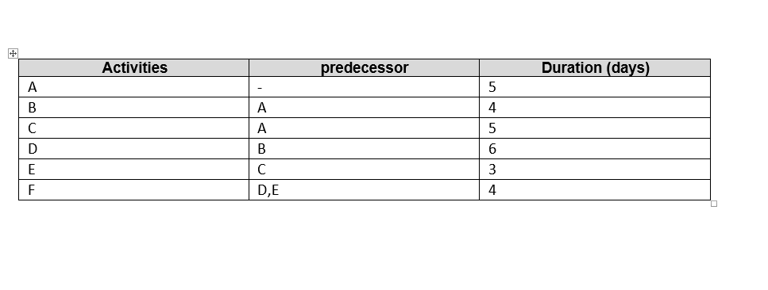

path1: A, B, D, F =5, 4, 6, 4 = 19 days (longer duration, the critical path)
B D
A F
C E
path2: A, C, E, F = 5, 5, 3, 4 = 17 days

3-Justify which activity would you crash based on some rationale (15%)
To justify the activity we rise the coast on the critical path (path 1) depending on the rule (high coast = low duration), and we choose the minimum requirements ctivity.

