Project management assignment
Elhaitham Nagem 2380
1-Develop a network diagram for the project specified below. (50 %)
2-Identify the Critical Activities and the total duration of the project. (35%)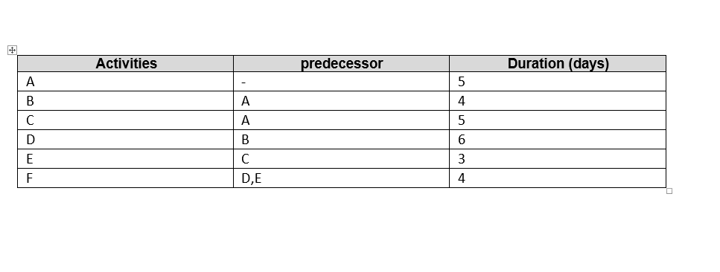

Path (1) : A, B, D, F =5, 4, 6, 4 = 19 days (longer duration the critical path)
B D
A F
C E
Path (2) : A, C, E, F = 5, 5, 3, 4 = 17 days

3-Justify which activity would you crash based on some rationale (15%)

In the activity, we increase the coast on the critical path ,(path) (1) in accordance with the rule (high coast = short time), and we choose the activity's minimal criteria.

