

Libyan International Medical University
Faculty of Basic Medical Science

Department of Biomedical Science (Microbiology)
YEAR 2 MED / Block of renal system
incident rate of Asymptomatic bacteriuria among LIMU
mabrouka Ramadan / 2342
Supervisor's names
د. انتصار الناجي

Assistant by :
أ. ناجي الحمري -
أ. أسماء الكوافي -
المشرفيين فنيين المعامل

Abstract
Background : The diagnosis of urinary tract infections (UTIs) in institutionalized older adults is often based on vague symptoms and a positive culture. The high prevalence of asymptomatic bacteriuria (ABU), which cannot be easily discriminated from an acute infection in this population, is frequently neglected, leading to a vast over-prescription of antibiotics.
Aims and objectives :this study was carried out to determine the incident rate of Asymptomatic bacteriuria among LIMU
Method : A total 24 participant 2 group (12 female ) and (12 male) aim of this study to take sample from urine to show the incident rate of asymptomatic bacteriuria among LUMU
asymptomatic bacteriuria is presence of bacteria in the properly collected urine of a patient that has no signs or symptom of UTI
is very common in clinical practice and its incidence increases with age
Results : significant bacteriuria was noted in 3 as 9% from total number of females it including

Introduction
The diagnosis of urinary tract infections (UTIs) is common in long-term care facilities (LTCFs) and was shown to account for 22% of all infections and more than 50% of the antibiotic prescriptions in this setting. However, in institutionalized older adults, UTI is difficult to differentiate. .¹
from asymptomatic bacteriuria (ABU). ABU prevalence rates in LTCFs are high, ranging from 25 to 50% in women and from 15 to 40% in men , Such high ABU prevalence rates obviously compromise the value of a positive urine culture as a diagnostic criterion for UTI. In addition, assessing symptoms of a UTI is challenging in this population. Institutionalized older adults, especially those with mental impairment or chronic symptoms, are often incapable of recognizing or communicating the presence of symptoms Moreover, this geriatric population frequently exhibits atypical manifestations of acute disease and presents with nonspecific symptoms. As UTI can cause severe. .²
infections, practitioners are prone to diagnose a UTI relying solely on vague symptoms such as changes in behavior or changes in the appearance of urine rather than typical symptoms of a UTI such as dysuria, frequency or urgency Residents of LTCFs thus frequently receive antibiotics due to a suspected infection, resulting in a significant ,overuse of antimicrobials. Treatment of ABU in this population is however not recommended because of potential adverse effects and a lack of efficacy in preventing subsequent UTIs.³ Moreover, there is increasing evidence that ABU protects against infection
Asymptomatic bacteriuria is common, with varying prevalence by age, sex, sexual activity, and the presence of genitourinary abnormalities ,In healthy women, the prevalence of bacteriuria increases with age, from about 1% in females five to 14 years of age to more than 20 percent in women at least 80 years of age living in the community. Escherichia coli is the most common organism isolated from patients with asymptomatic bacteriuria. Infecting organisms are diverse and include Enterobacteriaceae , Pseudomonas aeruginosa, Enterococcus species, and group B streptococcus. Organisms isolated in patients with asymptomatic bacteriuria will be influenced by patient variables: healthy persons will likely have E. coli, whereas a nursing home resident with a catheter is more likely to have multi-drug–resistant polymicrobic flora (e.g., P. aeruginosa). Enterococcus species and gram-negative bacilli are common in men. .^{4,5} aim of this study to take sample from urine to show the incident rate of asymptomatic bacteriuria among LUMU

Materia and method
This study include 24 participants 2 group (group A12 male) and ( group B 12 female ) asymptomatic bacteriuria is presence of bacteria in the properly collected urine of a patient that has no signs or symptom of UTI is very common in clinical practice and its incidence increases with age
material
inoculating urine sample into the culture media and put it in the incubator for 24hr , in this antibiotic sensitivity test we use six type of antibiotic
the antibiotic : 1- IPM : imipenem 2-APX: ampicillin 3-CXM: ceprofixacin
4-DA: clindamycin 5-PB: polymyxin 6-AX: ampicillin
- need investigation before prescribed antibiotics
investigaton
routine analysis (RBC) special analysis,(when RBC elevated and to know if bacteria recurrent), X-ray and abdominal ultrasound
Serum creatinine , Antibiotic sensitivity ,testModulation of PH
To enhance the activity of antibiotic , prevent crystal urea , suppress microorganism growth , relieve Dysuria
Statistically analysis
Use the chi square in seftower pass statistically to analysis prevalence of AB in participants
result and discussion
A total 24 of participants were screened result of sample take from both male and female ,The result of males show 9 % no bacteria growth and female 16%, and there is no statistical significant for result with bacterial growth show statistical significant

Table 1: The association between bacteriuria growth and gender
Male (%) | Female (%)
9(75%) | 2(16.7%) | No growth
3(25%) | 8(66.7%) | No significant growth
0(0%) | 2(16.7%) | Significant growth
P – value 0.018

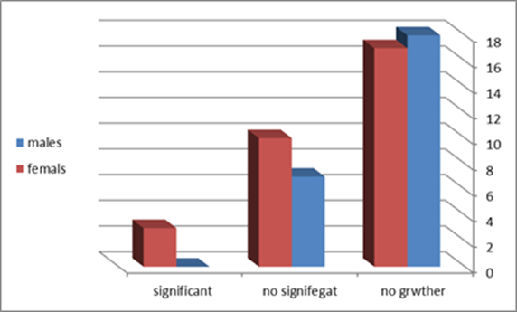
Table 2: The Chi-Square Tests of bacteriuria growth and gender

Chi-Square Tests
 | Value | df | Asymptotic Significance (2-sided) | Monte Carlo Sig. (2-sided) |  |  | Monte Carlo Sig. (1-sided)
 |  |  |  | Significance | 99% Confidence Interval |  | Significance | 99% Confidence Interval
 |  |  |  |  | Lower Bound | Upper Bound | Significance | Lower Bound | Upper Bound
Pearson Chi-Square | 8.727ª | 2 | .013 | .018^{b} | .014 | .021
Likelihood Ratio | 9.949 | 2 | .007 | .012^{b} | .009 | .015
Fisher's Exact Test | 8.180 |  |  | .018^{b} | .014 | .021
Linear-by-Linear Association | 8.065^{c} | 1 | .005 | .006^{b} | .004 | .008 | .002^{b} | .001 | .003
N of Valid Cases | 24
a. 2 cells (33.3%) have expected count less than 5. The minimum expected count is 1.00.
b. Based on 10000 sampled tables with starting seed 2000000.
c. The standardized statistic is 2.840.

CFUcat * Gender Crosstabulation
 |  |  | Gender |  | Total
 |  |  | Male | Female | Total
CFUcat | no growth | Count | 9 | 2 | 11
CFUcat | no growth | Expected Count | 5.5 | 5.5 | 11.0
CFUcat | no growth | % within CFUcat | 81.8% | 18.2% | 100.0%
CFUcat | no growth | % within Gender | 75.0% | 16.7% | 45.8%
CFUcat | non sig growth | Count | 3 | 8 | 11
CFUcat | non sig growth | Expected Count | 5.5 | 5.5 | 11.0
CFUcat | non sig growth | % within CFUcat | 27.3% | 72.7% | 100.0%
CFUcat | non sig growth | % within Gender | 25.0% | 66.7% | 45.8%
CFUcat | sig growth | Count | 0 | 2 | 2
CFUcat | sig growth | Expected Count | 1.0 | 1.0 | 2.0
CFUcat | sig growth | % within CFUcat | 0.0% | 100.0% | 100.0%
CFUcat | sig growth | % within Gender | 0.0% | 16.7% | 8.3%
Total |  | Count | 12 | 12 | 24
 |  | Expected Count | 12.0 | 12.0 | 24.0
 |  | % within CFUcat | 50.0% | 50.0% | 100.0%
 |  | % within Gender | 100.0% | 100.0% | 100.0%

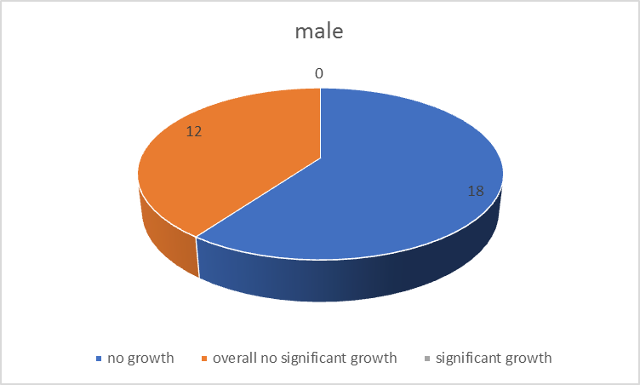

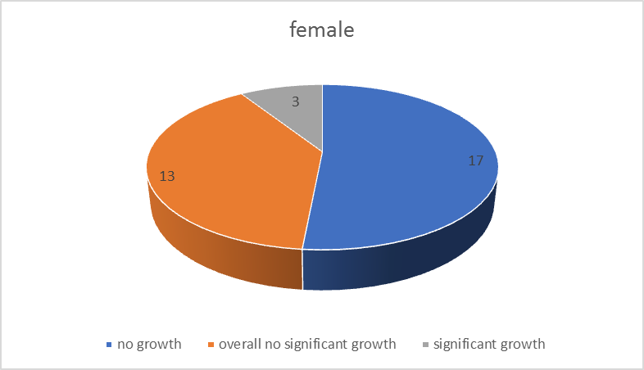

Ranks
 | sex | N | Mean Rank | Sum of Ranks
cfu | female | 12 | 16.58 | 199.00
cfu | male | 12 | 8.42 | 101.00
cfu | Total | 24

Report
cfu
sex | Mean | N | Std. Deviation
female | 20033.3333 | 12 | 37639.46993
male | 100.0000 | 12 | 286.03878
Total | 10066.6667 | 24 | 27951.00786

Because of these ambiguities, understanding which residents are prone to develop ABU is important and can help physicians to guide antibiotic treatment. While urine cultures from subjects with a high risk of having ABU should be interpreted with care, urine cultures from low risk groups have a higher diagnostic value. Older studies identified age, incontinence, functional disability, mental status and mobility as risk factors that are associated with an increased chance of having ABU. Although there are discrepancies between these studies, in general, more frail subjects have a higher risk of ABU. Longitudinal studies in the older adults report that the overall prevalence of ABU is rather static, but with high turnover rates, and conclude that ABU is a rather transient phenomenon with only a minority of people presenting with persistent colonization. .⁷ In this study, we identified prevalence rates, associated with ABU and long-term ABU in a LTCF. In addition, we recorded UTI 9% from all participants

conclusion and future
Institutionalized women with incontinence have ABU prevalence rates of about 9% and are often persistent carriers. Such prevalence rates should be considered in clinical decision making as they devalue the meaningof a positive urine culture as a criterion to diagnose UTIs. Diagnostic strategies are urgently needed to avoid antibiotic overuse and to identify patients at risk to develop upper UTI.
In the future, molecular diagnostics predicting bacterial pathogenicity or host susceptibility could help to identify those persons at risk of infection and requiring treatment.

References
1. European Centre for Disease Prevention and Control. Point prevalence
survey of healthcare-associated infections and antimicrobial use in
European long-term care facilities. April–May 2013. ECDC; Stockholm: 2014.

2. Nicolle LE. Asymptomatic bacteriuria and bacterial interference. Microbiol Spectr. 2015;3:1–25.
3. Nicolle LE. Urinary tract infections in the older adult. Clin Geriatr Med.
2016;32:523–38.

4. Juthani-Mehta M, Quagliarello V, Perrelli E, Towle V, Van Ness PH, Tinetti M.Clinical features to identify urinary tract infection in nursing home residents:a cohort study. J Am Geriatr Soc. 2009;57:963–70.

5. Sloane PD, Kistler CE, Reed D, Weber DJ, Ward K, Zimmerman S. Urine culture testing in community nursing homes: gateway to antibiotic overprescribing. Infect Control Hosp Epidemiol. 2017;38:524–31.

6. Cortes-Penfield NW, Trautner BW, Jump RLP. Urinary tract infection and
asymptomatic bacteriuria in older adults. Infect Dis Clin N Am. 2017;31:673–88.

7. Nicolle LE. Asymptomatic bacteriuria: when to screen and when to treat.
Infect Dis Clin N Am. 2003;17:367–94.

