Student name : Ayham ali fegy
Student number : 2642

Assignment to be submitted in Moodle by 19 March 2022
3Qs
Develop a network diagram for the project specified below. (50 %)
Identify the Critical Activities and the total duration of the project. (35%)
Justify which activity would you crash based on some rationale (15%)
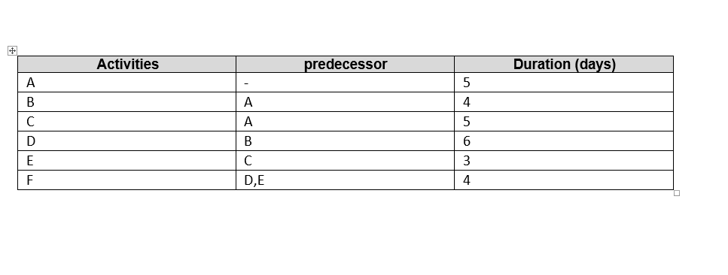
F
D
C
E
B
A

1-

2 -
Path number 1 : A -B –D- F = 5 + 4 + 6 + 4 = 19 day
Path number 2: A -C -E –F = 5 + 5 + 3 + 4 = 17 day
Total duration 19 day

3-It takes longer to complete and is located along the project's longest course.

Project E has three days, which gives it some leeway.

