Effect of Gender differences on prevalence and microbial spectrum of asymptomatic bacteriuria.

Student name: Nada Hassan Abdallah
Student number: 2729
University: Libyan International Medical University (AMS)
Supervisor's name: Dr.Intisar Alnaji
Dr.Naji Alhemri
Assistant by: Lab.Tech:Lujien Alshakmak

Abstract:
There are many factors that influence the urinary tract infection, such as: metabolic factors, social factors and physiological factors. This study concentrates to explore the association between the gender difference on the prevalence of asymptomatic bacteriuria. The method of this study includes 24 adult participant (12 males and 12 females). A result shows that there are significant association between gender and prevalence of urinary tract infection and it is more present in female’s patients. As conclusion, the gender plays important role in asymptomatic bacteriuria (urinary tract infection) as a risk factor. There are other studies that support the significance of this association.

Introduction:
Urinary tract infections (UTI) are a group of diseases that is caused by ascending of normal enteric flora which affect urinary system from urethra to urinary bladder and cause certain diseases such as cystitis (characterized by: dysuria, frequent, low urine volume, gross hematuria, penile discharge in male patients), pyelonephritis (characterized by: fever, nausea, vomiting, flank pain, dysuria) and prostatitis (with severe pain with prostate palpation, fever, dysuria) or it can be caused by hematogenous dissemination by blood stream. But asymptomatic bacteriuria reach bladder by only its ascending through urethra, not by blood dissemination and it did not present with any clinical manifestation of upper or lower tract infection. Diagnostic tests that detect UTI are urine microscopy that show if there are pyuria, hematuria and bacteria in urine sample. Urine dipstick is also useful to detect UTI, it is used to detect if there are any chemical disturbance in urine sample; positive hemoglobin, positive nitrite and positive hemoglobin are hallmarks of UTI in chemical study of urine. Finally, urine culture can identify any organism that cause UTI and also can help to identify the appropriate antibiotic that can treat the infection.
This experience will identify the incidence rate of asymptomatic bacteriuria among 24 LIMU students between males and females and it shows if there are growth of bacteria in their urine samples or there are no growth and it is measured by number of CFU/ml.

Materials:
-Flame.
-Urine samples.
-Calibrated wire loop (0.001ul or 0.01ul).
-Agar plate (5% sheep blood agar, MacConkey agar or CLED agar).
-Incubator.

Methods:
-Flame the calibrated wire loop to sterilize it from any microorganism.
-Insert it into the urine vertically to allow the adherence of urine in the loop.
-Remove the loop and it should be also vertically.
-Inoculate it in the agar plate with specific method; draw line in the middle of agar plate, then without reinflame the loop, streak it across the center inoculum to dilute it.
-Repeat the same method for other 23 sample.
-Incubate them at 37 C for 24 hours.
-If there are growth, count the colonies on each plate by multiplying the CFUs number by 1000 (if the used loop is 0.001 ml) or by 100 (if the used loop is 0.01 ml)
-The urine culture is negative If there are no growth or little growth even after 48 hours of incubation.

Results:
From 12 female samples there are:
-2 of them: shows 0 CFU/ml.
-4 of them: shows 100 CFU/ml.
-4 of them: shows 10000 CFU/ml.
-2 of them: shows 100000 CFU/ml.
And from 12 male samples there are:
-0 of them: shows 0 CFU/ml.
-2 of them: shows 100 CFU/ml.
-one sample shows 1000 CFU/ml.

Statistical analysis:
We can ask a question for analysis: Does growth of bacteria depend on gender?
Hypothesis: H0: No association between growth of bacteria and the gender.
Ha: There is an association between growth of bacteria and the gender.
The two involved variables are qualitative, so chi-square is the appropriate test to evaluate the association.
Chi-square test:
Spss output:

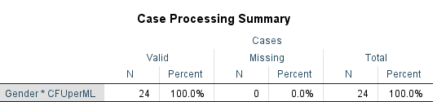
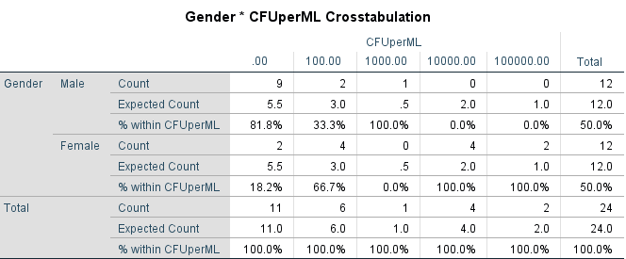
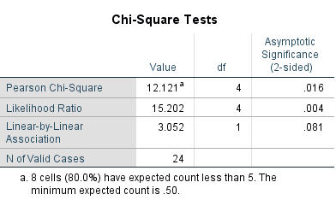
Since the p-value is less than alpha 0,05, there is association between bacterial growth and gender.
Decision: Reject null hypothesis (H0).
Conclusion: There is association between bacterial growth and gender, X2 (2, N=24)= 12.12, p=0.016.
Fisher ’s Exact test:
Hypothesis: H0: No association between growth of bacteria and the gender.
Ha: There is an association between growth of bacteria and the gender.
Spss output:

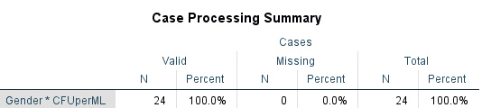
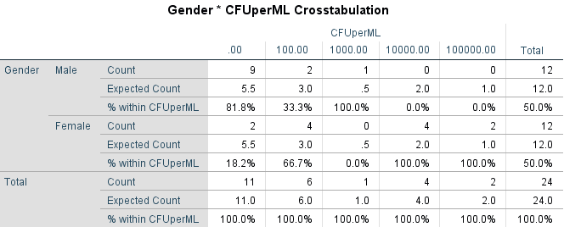
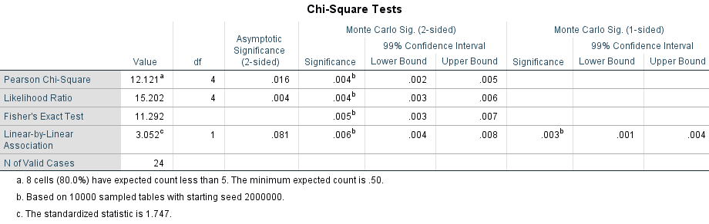
Decision: Reject the null hypothesis.
Since P-value less than alpha 0.05, we reject the null hypothesis.
Conclusion (Interpretation): there is association between bacterial growth and gender.

Discussion:
12 (50%) males and 12 (50%) females were included In this study. It was observed that 75% from 12 male’s samples are negatives (9 samples) and 25% (3 samples) shows overall no significant growth and 0% shows significant growth and approximately 16.66% from 12 female’s samples are negatives (2 samples) and 33.33% shows overall no significant growth (4 samples) and 50% shows significant growth ( 6 samples). Also, statistical analyses prove that there is significant relationship between the gender of patient and urinary tract infection.
According to these results we can conclude that the gender is a risk factor in urinary tract infection. So, female is predisposed to urinary tract infections than males because its anatomical nature of the urinary tract (short urethra and its near to the anus which is liable to fecal contamination), but the incidence increase in males at age of 60 because the prostate can enlarge and interferes with emptying of bladder. The incidence of asymptomatic bacteriuria depends in age and genre (male and female). It is uncommon in male patients and common in females and the incidence in women increase gradually with age (1% among school-aged women, more than 20% in 80 aged women). Pregnant women are more predisposed to UTIs and it can cause to serious symptomatic infection, hormonal changes in women can also increase prevalence of infection. Other studies done in adult patients with specific conditions revealed that women with 70 years age or older in community have 10.8-16% with asymptomatic urinary tract infection while 3.6-19% in men, and women with 70 years and older in a long-term care facility have 25-25% while 15-50% in men with same condition, and men with diabetes have 0.7-11% while it is greater than women. Therefore, according to our study and other studies inform that gender is associated strongly to asymptomatic bacteriuria.

Conclusion:
There are many risks that control the incidence of urinary tract infection, for example: age, sex and related disorders (diabetes mellitus, renal disease, transplantation of kidneys…). Age in turn can affect in sex because the increase in age lead to increase the risk of infection. To inhibit the development of the infection, it should identify the type of micro-organism in the sample by isolate it in another culture. The most common pathogens in UTIs are: Escherichia coli, klebsiella species, proteus species and Pseudomonas aeruginosa (health care–associated infections), then it must do the antimicrobial susceptibility testing (AST) to find out the appropriate antibiotic for the patient and to help the doctor to write the prescription.
References:
Bailey&scotts, diagnostic microbiology,13th ed. Elsevier MOSBY, 2014.
Levinson, Warren. Review of medical microbiology and immunology. Fourteenth Edition. The McGraw-Hill Companies, 2016.
Turkish Journal Of Family Medicine And Primary Care. Is There An Association Between Urinary Tract Infection And Toilet Type? ; 2021.
https://emedicine.medscape.com/article/2059290-overview. Published 2022. Accessed June 20, 2022.

