
LIBYAN INTERNATIONAL MEDICAL UNIVERSITY
APPLIED MEDICAL SCIENCES –SECOND YEAR
P.T.S. BLOCK
Assignment Lab 5

Name: Ahmed hasan salem alsahili Roll number: 2805 Group: A1
- Is there an association between systolic blood pressure (categories) and the risk of coronary heart diseases?
- Hypothesis:
H0 : No association between systolic blood pressure categories and coronary heart disease.
Ha : There is an association between systolic blood pressure categories and coronary heart disease.
- Assumption:
Random Sample: we will that the sample are randomly selected from the population
Independence: Observations are independent from each other ( Not matched pairs)
Sample Size:
- No more than 20% of the cells have expected count < 5
- The expected frequency (count) in each cell must be ≥1
- SPSS output:
Case Processing Summary
 | Cases
 | Valid |  | Missing |  | Total
 | N | Percent | N | Percent | N | Percent
chdfate * SBPCat | 4699 | 100.0% | 0 | 0.0% | 4699 | 100.0%

chdfate * SBPCat Crosstabulation
 |  |  | SBPCat |  |  |  | Total
 |  |  | normal | prehypertension | Stage1 hypertension | Stage 2 hypertension | Total
chdfate | 0 | Count | 1249 | 1107 | 562 | 308 | 3226
chdfate | 0 | Expected Count | 1107.4 | 1109.4 | 632.3 | 376.9 | 3226.0
chdfate | 0 | % within chdfate | 38.7% | 34.3% | 17.4% | 9.5% | 100.0%
chdfate | 0 | % within SBPCat | 77.4% | 68.5% | 61.0% | 56.1% | 68.7%
chdfate | 1 | Count | 364 | 509 | 359 | 241 | 1473
chdfate | 1 | Expected Count | 505.6 | 506.6 | 288.7 | 172.1 | 1473.0
chdfate | 1 | % within chdfate | 24.7% | 34.6% | 24.4% | 16.4% | 100.0%
chdfate | 1 | % within SBPCat | 22.6% | 31.5% | 39.0% | 43.9% | 31.3%
Total |  | Count | 1613 | 1616 | 921 | 549 | 4699
 |  | Expected Count | 1613.0 | 1616.0 | 921.0 | 549.0 | 4699.0
 |  | % within chdfate | 34.3% | 34.4% | 19.6% | 11.7% | 100.0%
 |  | % within SBPCat | 100.0% | 100.0% | 100.0% | 100.0% | 100.0%

Chi-Square Tests
 | Value | Df | Asymptotic Significance (2-sided)
Pearson Chi-Square | 122.916ª | 3 | .000
Likelihood Ratio | 123.347 | 3 | .000
Linear-by-Linear Association | 121.029 | 1 | .000
N of Valid Cases | 4699
a. 0 cells (.0%) have expected count less than 5. The minimum expected count is 172.10.

- Summary table:
Characteristic | Systolic Blood Pressure Groups |  |  |  | P-value
Characteristic | Normal | Prehypertension | Stage 1 hypertension | Stage 2 hypertension | P-value
Characteristic | 1613 | 1616 | 921 | 549 | P-value
CHD status[n(%)] |  |  |  |  | .000
CHD (no) | 1249(77.4%) | 1107(68.5%) | 562(61.0%) | 308(56.1%) | .000
CHD(Yes) | 364(22.6%) | 509(31.5%) | 359(39.0%) | 241(43.9%) | .000

- Conclusion:
- When the SBP is increased therefore the risk of coronary heart disease is increased, so there is association between SBP and CHD.
- It is reject the null hypothesis (p-value = .000).

Lab 6 : Correlation analysis &regression linear test
Ho : There is no corelation between DBP and SBP
H1 : There is a correlation between DBP and SBP 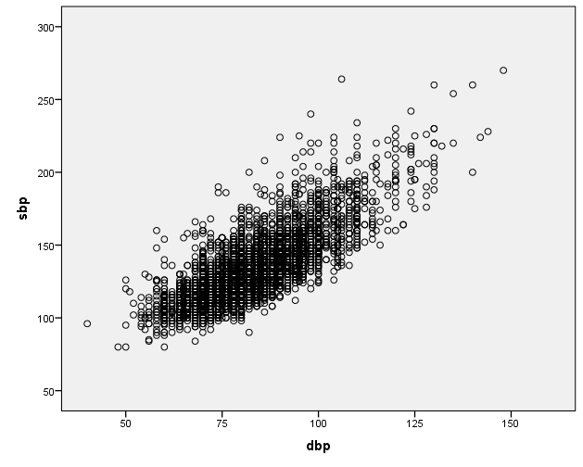
Ho : β=0; The slope is zero; there is no linear relationship between the 2 variables
Ha : β≠0; The slope is not zero; there is a linear relationship between the 2 variables

Assumptions :m
Normality
Independince
Equal variances
Linear relationships
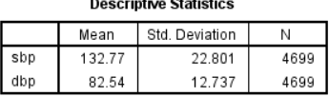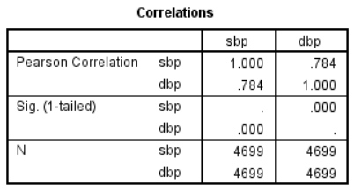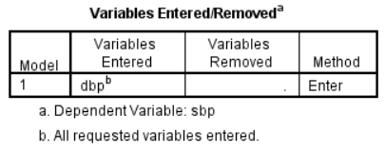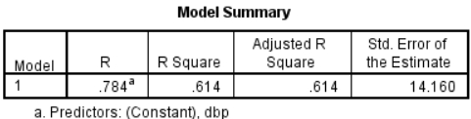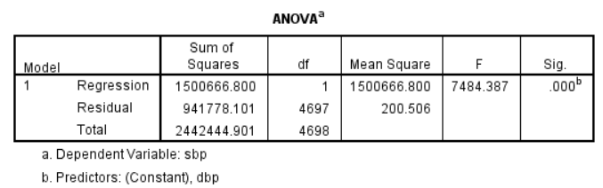
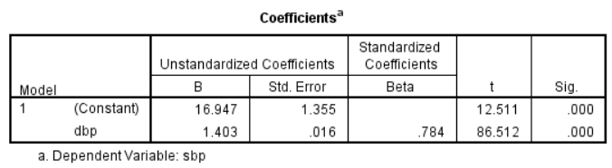
P-Value | Std.Error | *B | Variable
000. | 016. | 1.403 | Independant Variable
000. | 1.355 | 16.947 | Dependant variable
 |  |  | Intercept
 |  | 614. | R^2
The Equation : y(SBP) = 16.95-1.4 *(DBP)
If the DBP= 100 then the SBP should equal 123.05
61.4% of the variation in SBP is Explained by DBP
Pvalue = less than 0.05 so we reject null hypothesis
Conclusion : there is an assossiation between DBP and SBP ( 61.4 % )

