


Incidence Rate of Asymptomatic Bacteriuria Between Libyan International Medical School Female and Male Students

Ikram Saad El Gaoud 3140
Supervisor: Dr. Intisar Alnaji
Writing Advisor: Dr.Naji Alhomry
Faculty of Applied Medical Sciences
Libyan International Medical University

Table of Content:
Abstract: 3
Introduction: 4
Methodology: 5
Results: 7
Discussion: 11
Conclusion: 14
References 15

Abstract:
Asymptomatic bacteriuria is the presence of bacteria in a urine culture despite the patient not exhibiting any signs or symptoms. Urinary tract infections in general are very common. Nearly 1 in every 2 women and one in every 20 men get this infection in their lifetime. The prevalence of UTI is far more common in women than in men due to anatomical differences in urethra and its structure. Female urethras are shorter and closer to the anal region while men urethra are longer, providing better protection.

This study was done to test the prevalence of asymptomatic bacteriuria among students of Libyan International University. The study included 24 students. 12 female and 12 male. From the male patients, only 3 out of 12 had bacterial growth in contrast to 10 out of twelve for females. In other words, 16.7% of the sample had asymptomatic bacteriuria and they were female only.

Thus this study further reinforced that asymptomatic bacteriuria, and urinary tract infections in general, are indeed more prevalent in females than in males, especially during adolescence and childbearing years.

Introduction:
Urinary tract infections (UTI) are some of the most common infections. They constitute 25% of all infections in elderly patient. UTI are responsible for around 7 million office visits, 1 million emergency room visits and more than 100,000 hospitalizations each year.‎⁹
Urinary Tract infections are defined as an inflammatory response to bacterial infection in the urinary tract. The urinary tract is divided into: upper urinary tract, comprising the kidney and the ureters and an infection in it is called pyelonephritis. And the lower urinary tract comprising the bladder and the urethra and an infection in it is called cystitis. An infection, or rather, the presence of bacteria in the urine itself is termed Bacteriuria. Asymptomatic bacteriuria is the presence of bacteria in a properly collected urine sample without any accompanying symptoms of urinary tract infections.

The prevalence of UTI is much more significant in females rather than males and it shows a clear increase with age, with the exception of a spike in young women aged 14−24 years old.^{‎4} Adult women are in fact 30 times more likely than men to develop a UTI^{‎10} due to a number of different risk factors. The main risk factors are related to the anatomical structural differences in the genital tract between females and males. The female urethra is much shorter than a male urethra, with the measurements being 1.5 cm compared to a 7 cm respectively. Likewise, the female urethra is situated in much closer proximity to the anus than the male urethra. Both factors contribute to the ascending route theory of colonization, where intestinal normal flora colonize the perineum and ascend into the urethra and the bladder.^{‎1}

Diagnosis of Asymptomatic Bacteriuria happens with a positive urine culture that illustrates a significant quantity of bacterial growth. The quantitative criteria for that growth entail at least 100,000 Colony-forming Units (CFUs) for every one ml of urine in a voided midstream clean-catch specimen.^{‎2,‎7}

UTIs create a significant societal and personal burden. Furthermore, the quality of life measures are significantly impacted in patients suffering from recurrent UTIs^{.‎6} The purpose of this study is to explore the relationship between gender and Asymptomatic bacteriuria, hypothesizing that being female poses a greater chance of developing ASU than being male. Based on the analysis of the urine culture through the SPSS program, the null hypothesis: gender has no effect on ASU incidence rate between males and females can either be accepted or rejected.

Methodology:
A questionnaire was distributed to Libyan International Medical University (LIMU) students to ensure that subjects were not diagnosed with a UTI, had no prior antibiotic use and had no symptoms of urinary infection such as dysuria. The selected subjects were then brought and were given instructions on how to give the urine sample. A voided midstream clean-catch sample was obtained from 12 females and 12 males. In the midstream clean-catch the subject is first asked to urinate a small amount into the toilet bowl to flush any contaminated normal flora, then stop the flow of urine before proceeding to urinate a sample in a sterile cup until it is at least half full. The sample was pooled, filtered and then sterilized and used within the next hour or stored in a refrigerator at 4°C to be used in a span of no more than 18 hours to 1 day.

The sample was then mixed well and 5 or 10 ml was measured into the centrifugation test tube. After centrifugation, 9 out of the 10 supernatants were carefully removed to be subjected to inspection under the microscope. The suspension of sediment is 10-times concentrated compared to the original urine.‎²

The sediment is first inspected under 100-200x magnification at which the element distribution can be assessed for rare particles such as cast and epithelial cells. Next, the magnification is increased to 400x and at least 10 visual fields are randomly chosen to be examined for the presence of leukocytes, red blood cells and bacteria. The presence of leukocytes indicates pyelonephritis rather than cystitis.‎²

For the urine culture, the urine was first cultured on 5 % Sheep Blood agar. Meanwhile, for the differentiation of the microorganism MacConkey agar was used. The urine sample was mixed well and a 0.01 microliter plastic loop was inserted vertically in the sample and kept for a few seconds to ensure a fixed amount of urine is transferred for each petri dish. After dipping the loop, streak it down the center of the blood agar. Using the same loop streak around the center inoculum going left to right in a zigzag pattern to inoculate. Repeat the same steps for MAC agar. This technique helps spread the bacteria around the petri dish in a way that would isolate the CFU colonies so that they can be easily counted. Incubate the samples in a CO2 incubator at 37°C for 24-48 hours to ensure colonies growth on agar.

The number or colonies is counted and multiplied by 100 to obtain the CFU of bacterial growth per 1ml of urine. A numeric threshold of CFUs per milliliter has been established to avoid confusion with contamination of urine as it passes through the urethra.‎²

The microorganism morphology was noted and the organism identified. The MAC agar turned pink indicating that it is a lactose fermenting bacteria, and the colonies were non-mucoid differentiating E.coli from Klebsiella and affirming that most samples had E.coli growth.

The CFU were organized on a SPSS data sheet and further analyzed. The SPSS test used was Fisher’s test. Fisher's test is a test for independence between two qualitative variables. The assumptions for Fisher’s test are: sample is random, observations are independent and groups are mutually exclusive, all of which are met. Fisher’s test can also be used for a small sample size, which makes it ideal for this study.

Results:
Table 1: Subject CFU Count
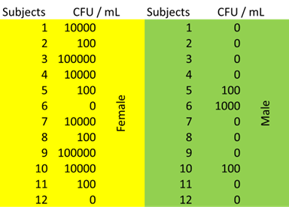

Table2: Categorizing CFU count into growth, significant growth and no growth.

 |  | Frequency | Percent | Valid Percent | Cumulative Percent
Valid | no growth | 11 | 45.8 | 45.8 | 45.8
Valid | growth | 11 | 45.8 | 45.8 | 91.7
Valid | significant growth | 2 | 8.3 | 8.3 | 100.0
Valid | Total | 24 | 100.0 | 100.0

Table 3: Categorizing Bacterial Growth and its Categories Vs Gender
 |  |  | Gender |  | Total
 |  |  | Males | Females | Total
Bacterial Growth | No Growth | Count | 9 | 2 | 11
Bacterial Growth | No Growth | % within Bacterial growth | 81.8% | 18.2% | 100%
Bacterial Growth | No Growth | % within gender | 75% | 16.7% | 45.8%
Bacterial Growth | No Significant growth | Count | 3 | 8 | 11
Bacterial Growth | No Significant growth | % within Bacterial growth | 27.3% | 72.7% | 100%
Bacterial Growth | No Significant growth | % within gender | 25% | 66.7% | 45.8%
Bacterial Growth | Significant Growth | Count | 0 | 2 | 2
Bacterial Growth | Significant Growth | % within Bacterial growth | 0% | 100% | 100%
Bacterial Growth | Significant Growth | % within gender | 0% | 16.7% | 8.3%
Total |  | Count | 12 | 12 | 24
 |  | % within Bacterial growth | 50% | 50% | 100%
 |  | % within gender | 100% | 100% | 100%

Figure 1: Bar Graph Illustrating Bacterial Growth By Gender
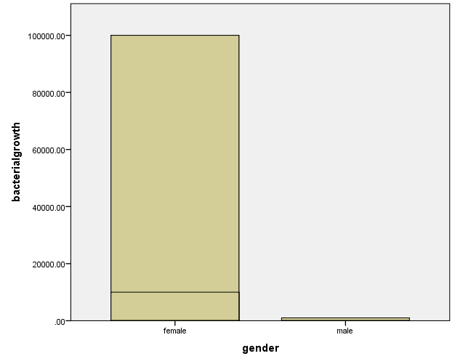

Figure 2: Bar Graph Categorizing Bacterial Growth Into Growth, No Growth and Significant Growth Vs Gender
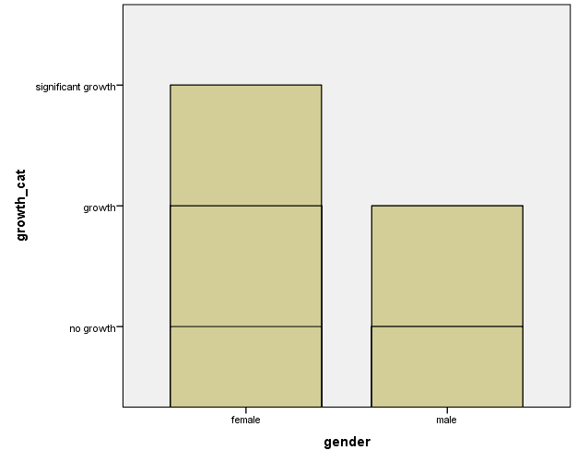
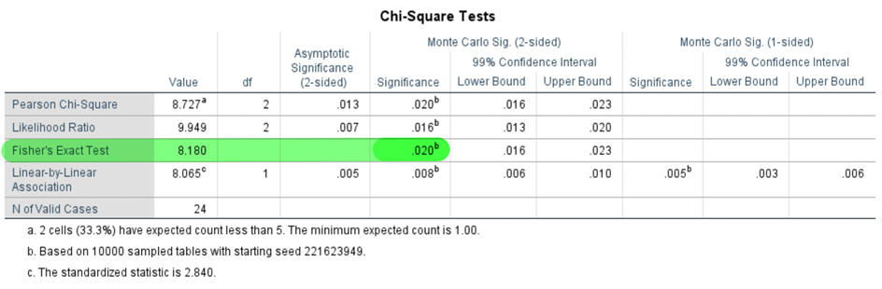
Table 4: Results of the Fisher’s Exact Test

Table 5: Summary Table

 | No Growth |  | No Significant Growth |  | Significant Growth |  | P-value
 | Count | Percent | Count | Percent | Count | Percent | 0.020^{b}
Females | 2 | 16.7% | 8 | 66.7% | 2 | 16.7% | 0.020^{b}
Males | 9 | 75% | 3 | 25% | 0 | 0% | 0.020^{b}

Discussion:
24 samples were collected from 24 subjects: 12 females and 12 males. The samples were cultured, incubated and analyzed. 11 samples (45.8%) showed no bacterial growth. 11 samples (45.8%) showed growth that was less than 10⁵ CFU, and 2 samples (8.3%) showed significant growth that was more than or equal to 10⁵ CFU indicating ASU in accordance with the criteria.
As presented in Table 3, 75% of males and 16.7% of females showed no growth whatsoever. 25% of males and 66.7% of females showed growth, but the said growth was not enough to confirm ASU. This growth could be due to contamination of the sample either while culturing or during collection. On the other hand, 0% of males and only 16.7% of females showed significant bacterial growth that indicates ASU. This discrepancy between females and males aligns with the hypothesis presented earlier and could be due to the proximity of the female urethra to the rectum and the short length of the female urethra compared to that of the male.
That said, these statistics are not conclusive enough to state a correlation between ASU and gender. To have a conclusive and reliable analysis confirming the association between gender and ASU a P-value must be calculated through Fisher’s Exact test, to which results are illustrated on Table 4. If the P-value is greater than 0.05 the null hypothesis fails to be rejected. If the P-value is less than 0.05 the null hypothesis is rejected. In these calculations, the P-value is equal to 0.020. Thus, the experiment concludes to fail to reject the null hypothesis, which states that there is no association between gender and ASU. Hence, the conclusive results are: there is in fact a correlation between gender and ASU with a significant predilection for females.
Microscopic examination of the colonies revealed gram negative rods. While culturing on MAC and blood agar revealed lactose-fermenting, and beta-hemolytic colonies respectively. All of these findings point to the bacterium being E.coli. This is in accordance with prior studies that prove E.coli to be the most common causative organism of ASU.^{‎3,‎4,‎5}
A noteworthy study to mention is one that is strikingly similar to this experiment with the sole difference of it being conducted on patients exhibiting symptoms of UTI. In the study by Dr. Khalifa AA Fatnasa done in 2013 title, Urinary Tract Infection In Sobrata, Algmel Cities In Libya 2013 the women ratio was significantly higher than men 301 women and 66 men in Sobrata city and 354 women and 171 men in Algmel city. The study concluded that, as proven here, E.coli is, in fact, the major cause for UTI, and that indeed females were more affected than males except in the cases of Klebsiella pneumoniae, and Streptococcus faecalis where men were more affected. The different statistics are outlined in Table 6.‎⁴
Table 6: Bacterial Species in UTI according to gender.⁴
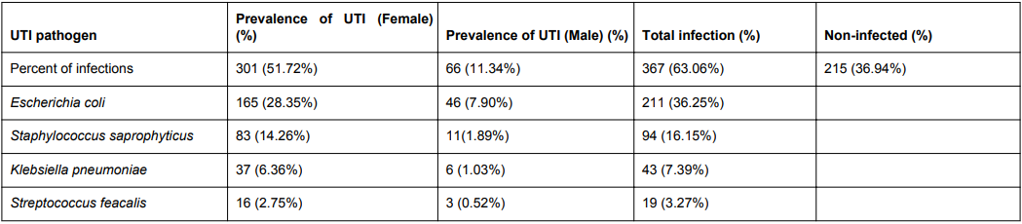

This experiment’s results can not be considered fully reliable due to a few different factors. For one, this experiment used theoretical data, and that interfered with the SPSS results. Secondly, the sample size used in this experiment is far too small. In this experiment there was a total of only 24 subjects, 12 of them female and 12 male. In comparison, Dr. Khalifa AA Fatnasa’s study included a total of 1508 patients.^{‎4} For this study to be remotely reliable a minimum of 100 patients should have been acquired. This way, outlier data would not screw the results as much and could be considered to reflect the general public to a greater extent. Thirdly, this study was limited to a specific population which gives a kind of false result. The population of which this study was conducted was of LIMU students in Libya. Assumptions that could accurately be made of this population are as follows: that the majority is comprised of adolescent males and females whose age ranges from 18-25, and that the majority of these students are not married and hence not sexually active (given that the experiment was conducted within the conservative libyan society). Restricting the sample of the study to such a population immensely alters the results. Age plays a very important factor in the prevalence of ASU. Though it is true that in adolescent years UTIs are more common among women than men, it cannot be ignored that the prevalence in elderly men and women is similar.^{‎12} The sexaual activity status of the subjects is also of utmost importance when diagnosing and researching UTI The predominant UTI risk factors in young women are sexual intercourse and the use of spermicidal contraceptives and the case is similar with adolescent young men.‎¹² Albeit UTI is not as common among adult men younger than 50, within this population the symptoms are almost always due to sexually transmitted infections related to the urethra and the prostate. All of these factors should be considered when discussing the results obtained from this experiment.
Another experimental error that was conducted was the fact that Diabetes Mellitus was not considered as a factor when screening for the subjects. UTI is a common infection observed in diabetic patients, altering the genitourinary tract and leading to UTI which can cause severe complications.⁴ Like so, being diabetic does not only increase the risk of acquiring UTI but also increases the risk of its recurrence. For glycosuria, colonization by a different uropathogen and impaired granulocyte function are among the most prominent risks of recurrence of UTI.‎⁴ If the percentage of diabetic patients in this experiment was substantial, this would critically alter the results obtained.
Thus, a recommendation to fix this error is to issue a survey or questionnaire inquiring about the sexual activity of the subject, whether or not they were diagnosed with diabetes along with any other health issues; and to include them in the data and SPSS analysis provided.

Conclusion:

Asymptomatic Bacteriuria is the presence of urine without manifesting any UTI symptoms. It is a very common medical phenomenon with prevalence more in females than in males. In this experiment, 16.7% of females had significant growth indicative of ASU. In comparison, 0% of males had significant growth indicative of ASU. The most common isolated organism in ASU is E.coli. If this experiment is to be redone, the emphasis must be put on collecting a larger sample for more conclusive results. This study served to spread awareness for ASU and its difference from UTI.

References

- 1995: 141(2):145-157. Abu Heidar, N.F., J.A. Degheili, A.A. Yacoubian, and R.B. Khauli. "Management of Urinary Tract Infections in Women:A Practical Approach for Everday Practice." Urol Ann, 2019: 11(4):339-346.
- Alnagi, Intisar. "Urine Analysis." LIMU Microbiology, Renal Block Med Year 2. Benghazi: LIMU, 2022.
- Christiano, Donna. "E.coli and UTIS (Urinary Tract Infections): The Common Connection." The HealthLine. 16 December 2019. https://www.healthline.com/health/e-coli-uti#E.-coli-and-UTIS (accessed June 10, 2022).
- Fatnasa, Khalifa A.A, Alaa Othman Harb, and Abdalhamed M Alkout. "Uriniary Tract Infrction in Sobrata, Algmel Cities in Libya 2013." Waalsh Medical Media. Clinical Microbiology:Open Access. 2013. https://www.walshmedicalmedia.com/open-access/urinary-tract-infection-in-sobrata-algemel-cities-in-libyya-2327-5073.1000163.pdf (accessed July 1, 2022).
- Givler, Donald N., and Amy Givler. "Asymptomatic Bacteruria." StatPearls Treasure Island, January 2022.
- Levinson, Warren E. Medical Microbiology and Immunology. United States of America: McGraw-Hill Education, 2016.
- Medin, M Median, and E Castillo-Pino. Therapeutic advances in Urology. 2 May 2019. https://www.ncbi.nlm.nih.gov/pmc/articles/PMC6502976/#:~:text=Another%20Columbian%20study%20showed%20a%25%20and%2015.7%25%2C%20respectively (accessed June 26, 2022).
- Orenstein, R., and E.S. Wong. "Urinary Tract Infections in Adults." American Family Physician, 1999: 59(5):1225-1237.
- Ruben, F.L., S.R. Dearwater, C.W. Norden, and et al. "Clinical Infections in the Noninstitutionalized Geriatric Age Group:Methods Utilized and Incidence of Infections." Am J Epidemiol,
- Schemiemann, G, E Kneihl, K Gebhardt, and et al. The diagnosis of Urinary Tract Infection a Systematic Review. Refrences Deutsches Arzteblatt International, Scientific Research Publishing, 2010, 361-367.
- T.M., H.R.D.H. "Urinary Tract Infection Risk Factors and Gender." The Journal of Gender-Specific Medicine, 2 July 2022.
- What is the Prevalence of Urinary Tract Infection in males? 17 October 2021. https://www.medscape.com/answers/231574-7822/what-is-the-prevalence-of-urinary-tract-infection-uti-in-males (accessed June 26, 2022).

