Libyan International Medical University

Faculty Of AMS

2ND Year Medicine (2021-2022)

Utility of point -of-care gram stain by physicians for urinary tract infection in children < 36months

widad mohammed alfetouri
student number: 2891
supervisors: Dr Iman Fergani
Dr Naji alhamry
Dr Intisar
Dr Senussi

Abstract :
Urinary tract infection in children is a significant problem that is frequently caused by Echerishia coli and necessitates prompt diagnosis and treatment to avoid recurrent UTI and renal scarring.
The purpose of this study was to assess the utility of a point-of-care Gram stain by a physician on suspected UTI in children as an arapid diagnostic test.
The research was carried out between January 2011 and December 2015.
Patients aged 36 months or younger who were examined in the emergency room had probable UTI.
Gram stain was conducted on a single specimen for urine culture, urinanalysis, and point of care.
We compared the diagnostic performance of fast diagnostic tests (pyuria, Gram stain at the point of care, or both).
Kappa statistics were used to assess the degree of agreement between the results.
We also looked at which antibiotics were more vulnerable to germs found in urine culture findings.
The sensitivity and specificity of Pyuria were 73.2 percent and 95.1 percent, respectively, of the 1594 patients analyzed in the study, using urine culture as the gold standard for UTI, whereas those of the point-of-care Gram Stain were 81.4 percent and 98.2 percent.

According to our findings, the point-of-care Gram stain is an effective quick diagnostic technique for suspected UTI in young children.

Introduction :
urinary tract infection ( UTI ) represent one of the most significant causes of serious bacterial infection in the pediatric population .
Adelay in treatment may result in repeated UTI and scarring of the urinary tract , leading to renal failure .
Therefore , appropriate use of antibiotics for UTI immediately after diagnosis 15 imperative .
However , diagnosing UTI by medical history or a a physical examination alone is difficult for infants and young children.
A recent study on fast urine tests 95 clinical studies and 95,703 children (18 years of age) were included in the study for UTI in children, with wrine culture sensitivity and specificity Urine Gram stain was 91 percent and 96 percent, respectively, while Pyuria was 74 percent and 86 percent.
While the urine Gram stain is useful, the guidelines do not include the results as part of the diagnosis of UTI because its utility in comparison to pyuria is still controversial.
The purpose of this study was to see if Gram stain was effective for suspected UTI in children.
The particular goals were to compare the validity of Gram stain vs urine cultures and to assess the appropriateness of antibiotic selection based on Gram stain results.

Materials and methods :
Urine samples were obtained using a sterile manner and transported and processed within 2 hours , Urine culture and Gram staining were performed on a single urine specimen before antibiotics were administered.
materials used :
- solutions of Crystal violet , Gram's jodine , 95 % ethanol and / or isopropanol acetone mixture ( 3 : 1 v / v ) , and Safranin.
- clean glass slides.
- wire or plastic loops.
- Bunsen Burner.
- Bibulous paper.
- Microscope.
- immersion oil.
- Difco.
- slide warmer.
- staining rack.
- Bacto Gram stain Reagents frism Difco for the three step Gram Stain.
figure of Gram Stain Aprepared slide with urine is stained with the Crystal violet.
its followed by treatment with an iodine Solution , to increase the interaction between The bacterial cell and the dye so that the dys is moretightly bound.


Decolorization was achieved by washing with 95 percent ethanol on isopropanol - acetone.
Crystal violet - lodine is retained by Gram - positive bacteria. Gram - negative bacteria lose their crystal violet - iodine and turn colorless when washed.
The smear is then counterstained with a different color abasic dye (Safranin).
The Gram - negative bacteria stained pink and Gram - positive bacteria dyed deep purple.
Following that, antibiotics for UTI were chosen. The first-line therapy is based on the most common organism recovered in cultures and Gram staining, which is Gram - negative rods (E - coli, Klebsiella), and second-generation cephalosporing is indicated.
Clinical data was examined and statistically analyzed.

Results :
During the study period, 1594 urine cultures were processed.
This study's clinical and laboratory characteristics are listed in the table below. 2.9 percent of patients had no urine cultures, urine analysis, or Gram stain.
Because of regular catheterization, 0.1 percent of patients were excluded. Of the remaining 1546 patients, 45 percent were girls with a median age of 3 months, and 12 percent had a pathogen discovered in cultures.
Positive cultures were made up of 34% girls, with a median age of 3 months.
The sensitivity and specificity of Pyuria were 73.2 % and 95.1 % respectively , whereas the Gram stain had a sensitivity and specificity of 81.4 % and 98.2 % respectively .
table properties of rapid test UTI , of the 183 positive urine cultures , bacteria isolated were E.coli , Klebsiella spp .
table Bacteria isolated from urine Culture .

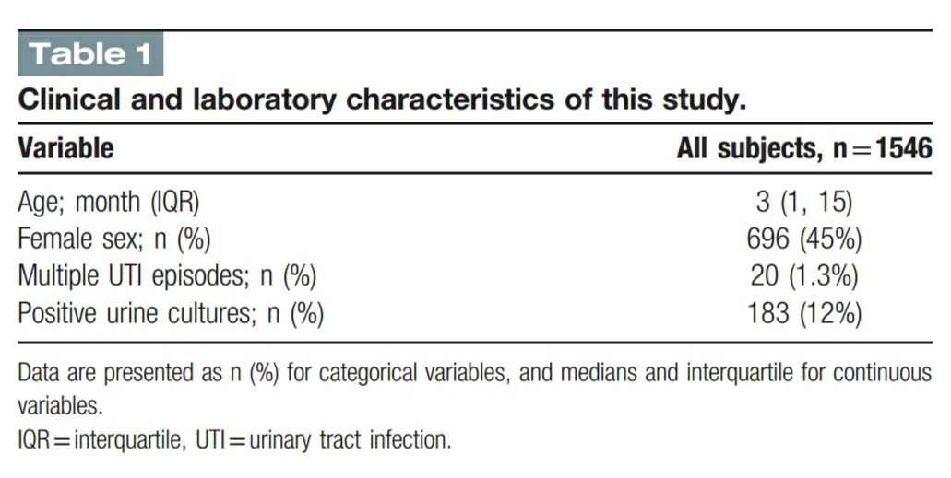
Discussion :
Gram stain was found to be superior than Pyuria as an arapid diagnostic test for UTI. However, when both pyuria and Gram stain were positive, the sensitivity was 100% .
The Gram Stain is a fast diagnosis for UTI that can be performed rapidly and at a low cost.
The presence of at least one bacteria on a Gram stain indicates a bacterial count of >10^5 CFU/mL for clean - catch, and the absence of bacteria in several fields on a Gram stain indicates a probability of fewer than 10^4 bacteria/mL.

Furthermore, we show that antibiotic selection based on Gram stain was superior to suggested empirical therapy.
Finally, the study's application to all patient populations is limited. Despite the fact that the study's suggestion is that physicians perform gram stain on urine samples since they were accurate in their interpretation.

Conclusion :
our findings indicate that the Gram stain is a good fast diagnostic technique for suspected UTI in children under the age of 36 months.
When compared to empirical therapy guidelines, antibiotic selection based on point-of-care Gram stain is preferable.

Reference :
Yodoshi T, Matsushima M, Taniguchi T, Kinjo S. Utility of point-of-care Gram stain by physicians for urinary tract infection in children ≤36 months. Medicine (Baltimore). 2019;98(14):e15101.
doi:10.1097/MD.0000000000015101.

Effect of Gender differences on prevalence and microbial spectrum of asymptomatic bacteriuria.
Hypothesis:
H0 : No association between gender status and bacterial growth .
Ha : There is an association between gender status and bacterial growth .

SPSS Output:

Summary table :
p-value of Fisher’s is 0.019
Decision:
except to reject the null hypothesis (FTR) Since P-value lesser than alpha 0.05, we except to reject the null hypothesis.

Conclusion :
there is association between gender status and bacterial growth .

